

GREAT TORRINGTON TOWN COUNCIL

Minutes of the Full Council Meeting held on Wednesday 2nd September 2026 at 7pm in the Committee Room, Great Torrington Town Council, Castle Hill, Great Torrington

MEMBERS PRESENT:
Cllrs K Allin, P Cloke, J Insull, J Isaac, D Maisey, S Mills, D Parish (Chair) and D Smith

ALSO, PRESENT:
Jennie Smithson, Town Clerk and Charlotte Kirby, Deputy Town Clerk

COUNCIL REFLECTION
Cllr Parish read the Council Reflection to start the meeting.
- APOLOGIES
The following Members gave their apologies in advance of the meeting with apologies being proposed and seconded to be accepted. Vote outcome:
Member | Reason | For | Against | Abstained | Outcome
Cllr C Bright | Holiday | 8 | 0 | 0 | RESOLVED
Cllr L Bright | Holiday | 8 | 0 | 0 | RESOLVED
Cllr Ashley-Martin | Ill health | 8 | 0 | 0 | RESOLVED
Cllr Brown | Ill health | 8 | 0 | 0 | RESOLVED
Cllr Kite | Childcare | 8 | 0 | 0 | RESOLVED

DECLARATION OF INTERESTS
Cllr Mills declared an Other Registerable interest in agenda item 22 (Member Updates); Cllr Mills declared an Other Registerable interest in agenda item 25 (Events: Remembrance); Cllr Allin declared an Other Registerable interest in agenda item 14 (Rack Park).

POLICE REPORT
Members were provided with links to local crime data on the Devon & Cornwall Police website. The Town Clerk met with the local PCSO last week who reported that there have been several incidents of antisocial behaviour over the summer months. There have also been several cases of abandoned cars. The police are investigating. Members were reminded to encourage members of the public to report crime and where possible provide evidence to support identification and prosecution. The Clerk highlighted the Crimestoppers service, and Operation Snap.
Members asked the Town Clerk to thank the PCSO for everything she does in the town and requested that the local police team be asked whether the second PCSO position is due to be filled.

Approval to suspend Standing Orders 3f, g &h was proposed and seconded. Vote outcome:
For | Against | Abstained | Outcome
8 | 0 | 0 | RESOLVED

PUBLIC CONTRIBUTIONS
None.

GUEST SPEAKER: UPDATE FROM THE STEERING GROUP OF THE DEVON DATA CENTRE AND BESS ACTION GROUP
Two members of the steering group presented to Members on the work they are doing in relation to the proposal to build a data centre and BESS in Great Torrington parish. They have established a number of different sub-committees with different specialities and are working closely with the CPRE.

REPORT FROM COUNTY COUNCILLOR: CLLR COTTLE-HUNKIN
Cllr Cottle-Hunkin supplied her full report in advance of this evening’s meeting and provided Members with a summary in-person (see Appendix A).

Approval to reinstate Standing Orders 3f, g &h was proposed and seconded. Vote outcome:
For | Against | Abstained | Outcome
8 | 0 | 0 | RESOLVED

REPORT FROM TORRIDGE DISTRICT COUNCILLORS: CLLR D SMITH
Cllr Smith advised Members that there had been no August meetings therfore no updates to report.

CONFIRMATION OF MINUTES

Full Council Meeting minutes: 22 July 2026
Approval of the meeting minutes was proposed and seconded. Vote outcome:
For | Against | Abstained | Outcome
8 | 0 | 0 | RESOLVED

The following meeting minutes were noted by Members:

Draft Planning Committee Meeting minutes: 22 July and 12 August 2026

Draft HR Sub-Committee Meeting minutes: 16 June 2026

Draft Environment Committee Meeting minutes: 14 July 2026

MATTERS ARISING
- Maternity services at North Devon District Hospital: an update on the latest situation has been shared with Members. ACTION: The Town Clerk will chase Sir Geoffrey Cox for a response to the letter sent by Members regarding services.
- Full Council 22 Jul 2026, minute number 92: Supershoes Window Dressing: the window dressing competition has been launched and the Mayor will judge windows on Saturday.
- Full Council 22 Jul 2026, minute number 102: Data Centre survey: the survey for local residents has been issued and will be delivered to homes in and around Great Torrington this week. Quite a few responses have been received so far.

CORRESPONDENCE AND MATTERS BROUGHT FORWARD BY THE CHAIR AS A MATTER OF URGENCY
- Councillor vacancy: Torridge District Council (TDC) has confirmed that the Town Council can now start advertising the councillor vacancy for co-option.
- St Michael’s Church: Sunday’s Eucharist at St Michael’s will include Archdeacon Verena from Barnstaple taking communion. This is a historic moment for Great Torrington. The service will take place at 10am.
- Bus Shelters: The Town Council has been approached by Devon County Council offering to replace 5 of the 7 bus shelters. This will form part of a contract until 2041 with Fernbank who will be responsible for bus shelter maintenance. The new shelters will include advertising, but this will be carefully managed on the bus shelters near the school. Shelters to be replaced are: 2 at Lidl, 2 at GTS and 1 at Dartington Fields.
- South West Ambulance Charity: the charity (who this council donated to recently) has informed us they have been subject to a data breach. The Town Council’s contact details may have been shared as part of the breach, however our contact details are already in the public domain. No bank details were affected.
- Dangerous Driving: The Town Council has been approached by a number of local residents regarding dangerous and antisocial driving in the town (Halsdon Terrace and Sydney House car park) recently. The PCSO has been informed and local residents are being asked to try to record vehicle registration numbers and obtain photographic/video evidence of the incidents. CCTV will be installed soon which will help with managing these incidents.
- Ghana Sister City: The Mayor has been approached by a district in Ghana (Shama) regarding potentially ‘twinning’ with them. They are currently twinned with South Molton. With Members’ agreement, the Mayor is going to investigate this further. Cllr Smith suggested prioritising ‘twinning’ with the region in India associated with Sister Nivedita.
- Bus Timetable Changes: Bus 75 from Bideford to Torrington has now merged with the 317 timetable. Members queried whether the number 75 Sunday service will continue. ACTION: Cllr Cottle-Hunkin will check.
- Xlinks request for private meeting with Town Council: The Mayor invited representatives from Xlinks to attend a standalone extraordinary council meeting however they have declined this invitation. Members expressed their disappointment with this outcome.

QUESTIONS FROM MEMBERS SUBMITTED NO LATER THAN NOON, TUESDAY 1ST SEPTEMBER 2026
None.

LOCAL GOVERNMENT REORGANISATION (LGR) UPDATE:
A small group of councillors met to discuss potential asset transfers as a result of LGR. A report summarising the outcome of the meeting was shared with all Members prior to this meeting. The meeting agreed that the Council needs to agree a set of principles to help guide with the decision-making process regarding asset transfer. Members confirmed they are happy with Officers continuing to investigate the implications of taking on certain priority assets identified during the meeting should they be offered to the Town Council.

RACK PARK:
Currently grounds maintenance for Rack Park (which is owned by Great Torrington Town & Lands Charity) is undertaken by TDC. TDC’s contract to provide this service ends in early 2027 and the Town Council has been asked if it would like to take over the contract, and if so, on what terms.
Members debated the issue: it was proposed and seconded that the Town Council should take on some of the grounds maintenance activities for Rack Park. Vote outcome:
For | Against | Abstained | Outcome
7 | 0 | 1 (Cllr Allin) | RESOLVED

It was proposed and seconded that the Town Council puts forward a bid to charge staffing plus on-costs with additional charge for expenses such as fuel, tools and machinery maintenance associated with grounds maintenance. Vote outcome:
For | Against | Abstained | Outcome
7 | 0 | 1 (Cllr Allin) | RESOLVED

ALLOTMENT TENANCY AGREEMENT
Following a review of a revised allotment tenancy agreement template by the Policy & Finance Committee earlier this year, the National Allotment Society’s Legal Advisor was asked to review and confirm acceptability of the template. Some minor alterations were proposed (see report) and it was proposed and seconded to approve the new template including these revisions. Vote outcome:
For | Against | Abstained | Outcome
8 | 0 | 0 | RESOLVED

Members requested that in future, new tenants are given a formal induction to the allotment site with a health and safety briefing, details of what they are/are not allowed to take on site and a photograph of the plot taken at the point of the plot being taken on by the new tenant. New tenants will also be supplied with a new guidance leaflet.

NOTICEBOARD
The new Town Council noticeboard has been installed. Professional help was required to install the board which wasn’t previously accounted for when agreeing the budget for this item. The additional cost was £95.
It was proposed and seconded to approve this additional spend from the General Admin budget code. Vote outcome:
For | Against | Abstained | Outcome
8 | 0 | 0 | RESOLVED

CHRISTMAS LIGHTS COLOUR CHOICE
New icicle lights are to be purchased for the town centre this Christmas. Members were given the option of buying the same style of lighting as we currently have (warm white with cool white twinkle) or a new option (blue with cool white twinkle).
It was proposed and seconded to order the warm white with cool white twinkle. Vote outcome:
For | Against | Abstained | Outcome
8 | 0 | 0 | RESOLVED

LET’S CELEBRATE TOWNS 2026
The Town Council has been approached by The Globe Project Manager regarding this initiative. It will be discussed at the next Regeneration Board meeting in two weeks, however it will require Town Council involvement.
It was proposed and seconded that this initiative be supported in principle by the Town Council. Vote outcome:
For | Against | Abstained | Outcome
8 | 0 | 0 | RESOLVED

GENESIS SERVICE CHARGE
At the time of taking on the lease for the committee room, the Town Council was made aware that the service charge for the room would be charged annually in arears. This room incurs 44% of the charges for the office space occupied by the Town Council, with the other 3 offices making up 56% of the footprint/charges (paid for by TDC). The service charge for FY25/26 was not budgeted for in FY26/27.
Members requested more detail behind some of the charges on the invoice as well as information on how these charges are divided between other tenants.
It was proposed and seconded to approve payment for the FY25/26 service charges using funds from reserves. The charges will be reflected as a negative on the relevant budget code for FY26/27. Vote outcome:
For | Against | Abstained | Outcome
8 | 0 | 0 | RESOLVED

CCTV UPDATE
Plans for the installation of CCTV are moving forward. An application for a licence to install CCTV at the back of the Pannier Market has been submitted to TDC. A quote for signage has been requested. It is hoped the system will be up and running in October.

FINANCIAL UPDATE:
Approval of the following financial updates were proposed and seconded. Vote outcome:
Item | For | Against | Abstained | Outcome
Accounts Paid: July 2026 | 8 | 0 | 0 | RESOLVED
Bank Reconciliation: July 2026 | 8 | 0 | 0 | RESOLVED
Funds Transfer: July 2026 | 8 | 0 | 0 | RESOLVED
Summary of Payments over £500 | 8 | 0 | 0 | RESOLVED

WORKING GROUPS UPDATE:
- Increasing Physical Activity Working Group: It was proposed and seconded to disconnect this working group from the council as the aims of the group sit well within the remit of T100.
Vote outcome:

For | Against | Abstained | Outcome
8 | 0 | 0 | RESOLVED

- Badminton sessions: The Town Council has received high levels of interest in the council-sponsored badminton sessions proposed for October in conjunction with Atlantic Raquet Centre. They will be held on 4 Mondays in October. A credit card is required to book the sports hall at GTS for the sessions through their online booking system. It was proposed and seconded to approve the use of the Town Council’s credit card for this purpose. Vote outcome:
For | Against | Abstained | Outcome
8 | 0 | 0 | RESOLVED

- Emergency Planning Working Group: The Town Clerk is looking to hold a meeting of this group during week commencing 21 September.

2026/2027 PAY AWARD:
The pay award for FY26/27 has been confirmed at 3.3% and this will be implemented in the September payroll.

HEALTH & SAFETY:
Cllr Allin raised concerns with dog fouling, particularly on New Street. Members discussed options for tackling this issue and it was agreed to raise the problem with the Dog Warden at TDC. The Council can produce posters for local residents to put in their windows and pavement chalk spray stencils will be investigated.

EVENTS:
- Allotment Social: The allotment social event on 19th August was a great success, giving allotmenteers the opportunity to meet each other. Officers will look into the possibility of holding this event annually. Members thanked Kate for organising the event.

- Civic Service: This year’s Mayor’s Civic Service will take place at St Michael and All Angel’s church on Sunday 11th October at 10am. A parade will depart Sydney House car park at approximately 9:40am.

- Remembrance: This year’s Remembrance Sunday parade and service will take place on Sunday 8th November 2026 with the parade forming up and marching from Woodland Vale Care Home. This years’ service will include several members of the clergy from Great Torrington. A short service will be led by Fr. Steve Turner on Armistice Day (11th November) at 11am in the cemetery.

- Christmas Lights Switch-on: This event will take place on Saturday 28th November 2026. Officers are planning the event at the moment, hoping to replicate last year’s event with a children’s disco, airbrush tattooing for kids, children’s craft activity (lantern making) and carol singing with Torrington Silver Band. Immediately after the lights have been switched on, live music will be playing in the Town Hall for adults to enjoy.

FUNDING REQUESTS:
None.

MEMBER UPDATES:
- Torri Youth: The group is currently advertising for a replacement Youth Worker and will hold their AGM soon.

- Mayfair Committee: This committee’s AGM will take place on Tuesday 8th September. Members raised concerns about how the staffing changes at Bluecoat Primary School could impact training for the maypole dancing. Cllr Mills will investigate.

- The Globe Hotel: The deadline for applications for the main contractor at The Globe has now passed. The team are looking into ideas for ‘meanwhile use’ of specific sections of the building which will be renovated first: please share any ideas with the team at The Globe.

Closed session: To resolve to exclude the press and the public to progress matters of a confidential nature under the Public Bodies (Admission to Meetings Act) 1960.
Approval to move into the closed session was proposed and seconded. Vote outcome:

For | Against | Abstained | Outcome
8 | 0 | 0 | RESOLVED

INTERNAL AUDITOR:
Members were provided with 3 options for a new internal auditor. It was proposed and seconded that Option 1 be selected for a period of 1 year. Vote outcome:
For | Against | Abstained | Outcome
8 | 0 | 0 | RESOLVED

Vote to exit closed session:
It was proposed and seconded to come out of the closed session. Vote outcome:
For | Against | Abstained | Outcome
8 | 0 | 0 | RESOLVED

EQUALITY, DIVERSITY AND INCLUSION:
The council confirms that decisions made at this meeting were in line with Great Torrington Town Council policies.

DATE OF NEXT MEETING:
Full Council Meeting: Wednesday 7th October 2026 at 7pm.

Meeting closed at 8:58pm.

Signed ………………………………………… Date ………………………..

Appendix A: County Councillor’s Report
Proposed Hyperscale Data Centre and Battery Energy Storage System (BESS):
Many of you will already be aware of the proposals by Xlinks for a hyperscale AI data centre and Battery Energy Storage System (BESS) on farmland in Great Torrington. From the information we have heard and seen so far, I believe the proposals are entirely inappropriate for our area. The development would remove around 850 acres of productive farmland within the UNESCO North Devon Biosphere Reserve and would directly affect a landscape that includes two listed farmhouses. The visual impact would be immense, with structures visible for many miles across the surrounding countryside.
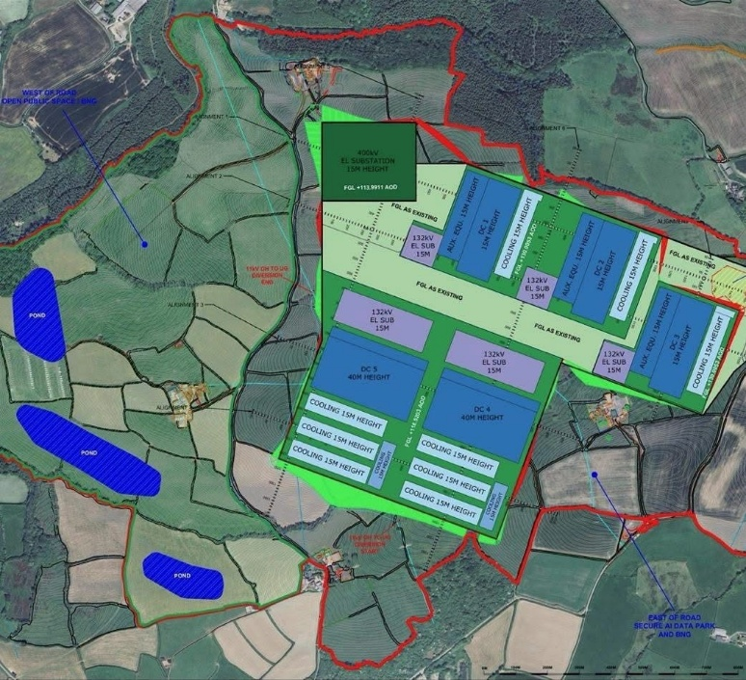
I would like to pay tribute to the tremendous work being undertaken by the local Action Group, whose volunteers have dedicated countless hours to researching the scheme. No Devon Data Centre — Protect Great Torrington farmland Through Freedom of Information (FOI) requests submitted to Torridge District Council, they have uncovered a significant amount of information that has helped reveal the true scale of what is being proposed. Much of the information released relates to pre-application discussions between the developer and the council; documents that are usually viewed as commercially confidential have been released publicly through FOI.
Figure 1: plans of the data centre released via FOI
What these documents reveal is deeply concerning. The most striking issue is the sheer scale of the proposal. Two of the largest data centre buildings would each have a footprint of approximately 22 ACRES! To put that into perspective, each building could accommodate the equivalent footprint of 18 Exeter Cathedrals and would be 40m tall. This is not a modest rural development or even a large industrial estate. It would be a monstrous industrial complex unlike anything currently seen in the region.
Questions also remain over water usage. Xlinks has publicly stated that the facility would be self-sufficient in water. However, documents obtained through FOI appear to tell a different story. They indicate that in an extreme dry year (sound familiar?!), annual water demand could be as high as 2.9 BILLION LITRES. Given the increasingly frequent periods of drought and pressure on water resources, residents are rightly asking how such demand could ever be considered sustainable… What is also concerning is that whilst Xlinks has told the press that the proposals being circulated are out of date, the documents released under FOI show these same designs were submitted to the council as recently as April 2026.
This scheme is being described as one of the largest AI data centre developments and battery storage facilities anywhere in the world. I simply do not believe that North Devon's countryside should be sacrificed for an industrial development of this magnitude. I will continue to challenge these plans and support the community's right to have its voice heard. If, like me, you believe this proposal should not proceed, I encourage you to support the campaign and sign the Parliamentary petition to get it debated in Westminster: https://petition.parliament.uk/petitions/776949
Bluetongue Outbreak:
The Bluetongue outbreak has been devastating for many livestock farmers across Devon and beyond, myself included. Whilst the disease poses no risk to human health or food safety, the impact on farming families, animal welfare and rural businesses has been profound. Bluetongue: latest situation - GOV.UK
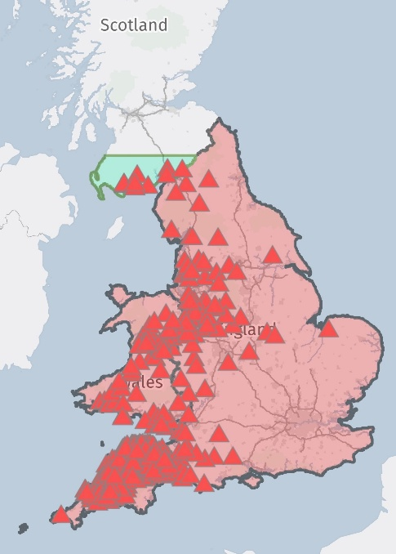
There are many lessons to be learned from this outbreak, and I believe some very difficult questions need to be asked. Most concerningly, here in Devon where the outbreak started, the virus was present and confirmed and yet farmers were left in the dark and were not alerted by Defra. That is quite simply inept and represents a failure by the very government body whose responsibility it is to protect animal health, safeguard welfare and provide confidence to the farming community.
Figure 2: confirmed bluetongue cases/infected premises
The availability of vaccine has also been a major issue. Many farmers who wanted to urgently protect their livestock found they were unable to access the vaccine due to the high demand and lack of vaccine in the country. At the same time, test results are taking weeks to come back, creating uncertainty and making it incredibly difficult to track exactly how quickly and where the virus is spreading.
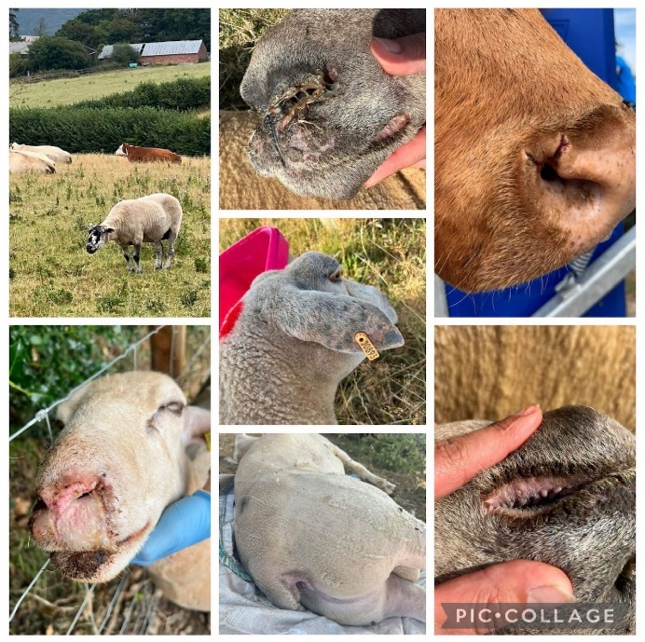
What has perhaps caused the greatest frustration is the lack of meaningful support. Farmers have faced substantial veterinary, medicine and vaccination bills, animal losses and carcass disposal costs. Behind the financial impact lies an enormous emotional burden. Watching your animals suffer, nursing them and seeing more and more animals with new symptoms day after day is extremely tough. Dealing with uncertainty and carrying the weight of additional financial pressures has taken a significant toll on the mental wellbeing of many farming families.
Figure 3: examples of bluetongue symptoms on our farm
Despite this, there has been no support from Government to help those affected at all.
I would like to place on record my sincere thanks to the Farming Community Network (FCN), whose volunteers continue to do an incredible job supporting farming families through what has been an exceptionally difficult period. Farming Community Network - Farming Community Network I would also like to thank the wider local community, veterinary professionals and neighbours who have been so supportive.
Looking ahead, I am now calling on our local MPs and the Government to work with industry, farmers, scientists and animal health experts to develop a funded, coordinated national Bluetongue strategy to ensure that this never happens again. Bluetongue BTV-3: Call for a National Plan - Farming Solutions Ltd
At present, the main message we hear from DEFRA is they are "monitoring the situation". That’s not good enough. Our farmers feed the nation, care for our countryside and underpin our rural economy. They deserve better than delayed communication, inadequate preparedness and a Government that appears content merely to observe events as they unfold.
Suspension of Birth Services at North Devon District Hospital:
The suspension of births at North Devon District Hospital should never have been allowed to happen.
Earlier this month, the Royal Devon University Healthcare NHS Foundation Trust was heavily scrutinised by Devon County Council's Health and Adult Care Scrutiny Committee, where serious concerns were raised about how the situation had been allowed to develop. The Leader of Devon County Council described the closure as a “catastrophic failure of senior management”, reflecting the frustration, anger and anxiety felt by many residents across North Devon and Torridge.

Throughout the scrutiny process, we highlighted the very real risks associated with expecting mothers having to make lengthy journeys whilst in labour- up to two hours in some cases. What makes this situation even more disappointing is that local people were repeatedly assured that the merger of services between Barnstaple and Exeter would make health services more resilient. It certainly doesn’t feel like it right now.
Figure 4: Both of my children were born at NDDH
I would like to acknowledge the considerable efforts of Ian Roome MP, who has been working tirelessly alongside families, healthcare professionals and local representatives to ensure that pressure continues to be applied to restore services as quickly as possible. The Trust has now indicated that it is hoping to reopen birthing services in Barnstaple by the end of September, and we sincerely hope that timeline can be achieved. However, restoring the service is only part of the challenge. There must also be a full and transparent review of how this situation arose and what safeguards are needed to prevent it from happening again. ‘This can never happen again’ – MP demands maternity answers
This issue goes beyond maternity services alone. It raises wider questions about the resilience and fragility of healthcare provision across North Devon District Hospital. If a core service such as maternity can be lost so suddenly, residents are right to ask what pressures may exist elsewhere within the hospital and wider NHS system. Rural communities deserve the same access to safe, high-quality healthcare as those living in cities and larger towns. Just because we live in a rural part of Devon does not mean we should be expected to accept reduced access to essential health services.
Local Government Reorganisation, Significant Changes Ahead for Devon:
One of the biggest changes affecting local services over the coming years is the Government's decision to reorganise local government across Devon. From April 2028, the current two-tier system of local government will come to an end. This means that Devon County Council and the District councils will be replaced by new unitary authorities, with a single council responsible for delivering all local government services in its area.
To help residents understand these changes, the eleven Devon councils have worked together to launch a new website called “Future Devon”, which provides the latest information on Local Government Reorganisation (LGR), explains why the changes are happening and outlines what residents can expect over the coming years. Local Government Reorganisation in Devon - Future Devon
Whilst the structure of local government is changing, services will continue to be delivered throughout the transition period. There is a significant amount of work taking place behind the scenes to ensure a smooth handover and minimise disruption for residents.
This is the most significant reform of local government in Devon for decades, and I will continue to keep you informed as plans develop and further details emerge.
Here is most recent info from our cabinet member for LGR Cllr Paul Arnott:
- Devon County Council will consider proceeding with a Judicial Review (JR) of LGR in Devon at its Cabinet meeting on 9th Sept 2026. It has already submitted its draft arguments to government, which were meant to be answered two weeks ago, delayed by MHCLG till 4th September. The JR can only argue for flaws in the processes during the government’s conduct of this matter. On the 9th, DCC Cabinet will decide if its own arguments about process are worth pursuing in the light of government’s proposed counter arguments, It is anticipated that all districts bar Exeter would write in support of the JR if submitted formally.
- Meanwhile, an immense pan-Devon collaborative process to prepare for the proposed new unitaries in May 2027 and Vesting Day in April 2028 is being led by a Senior Responsible Officer appointed by government, Donna Manson the CE of DCC. Each CE of the district councils has a leadership role working to her on an identified workstream. It is estimated that LGR is creating at least 30% more work for council officers at the moment, who are also having to maintain business as usual, with very little extra government funding. At DCC a Scrutiny Committee meets regularly to discuss and scrutinise these processes as they unfold.
- The response letters from all Devon Councils to the proposed warding arrangements for the new unitaries were completed on time. They were given three weeks and four days to submit to MHCLG’s warding proposals, a process which would usually take 18 months. This flows from government’s decision to give the Boundaries Commission no formal role at this stage, meaning that a number of glaring errors may not be corrected for five years. Discussions with government on this are ongoing.
- A letter has been sent co-signed by the leaders of Devon, Plymouth and Torbay Councils to government indicating a readiness to have a Devon Strategic Mayoral Authority for the 1.25 million people in Devon. It is understood that Cornwall may be offered a bespoke non-mayoral agreement. An indicative response from government is likely within a few weeks

