

GREAT TORRINGTON TOWN COUNCIL

Minutes of the Full Council Meeting held on Wednesday 22nd July 2026 at 7pm in the Committee Room, Great Torrington Town Council, Castle Hill, Great Torrington

MEMBERS PRESENT:
Cllrs K Allin, B Ashley-Martin, C Bright, P Cloke, J Insull, L Kite, D Maisey, S Mills, D Parish (Chair) and D Smith

ALSO, PRESENT:
Jennie Smithson, Town Clerk and Charlotte Kirby, Deputy Town Clerk

COUNCIL REFLECTION
Cllr Parish read the Council Reflection to start the meeting.

APOLOGIES
The following Members gave their apologies in advance of the meeting: Cllrs L Bright (ill health), Cllr Brown (ill health) and Cllr Isaac (work commitments)
Apologies were proposed and seconded to be accepted. Vote outcome:
For | Against | Abstained | Outcome
10 | 0 | 0 | RESOLVED

DECLARATION OF INTERESTS
Cllr Mills declared a non-registerable interest in agenda item 17 (Remembrance Planning); Cllr Mills declared a non-registerable interest in agenda item 19 (Market House); Cllr C Bright declared an Other Registerable interest in all agenda items.

POLICE REPORT
Members were provided with links to local crime data on the Devon & Cornwall Police website. Cllr Kite attended a recent Police Great Torrington & Rural Police meeting at which she raised the issue of vehicles speeding on Hatchmoor Road. There is a lack of signage regarding children crossing to access the schools (unlike on Calvesford Road). The PCSO will look into this in more detail.
Cllr Parish informed Members he had been contacted by a member of the public who had been the victim of two incidents of anti-social behaviour. The incidents have been reported to the police and there is CCTV footage of one of the incidents.
Cllr Mills expressed concern over the number of vehicles parking on double yellow lines in Well Street, causing issues with two-way traffic in the evenings.

Approval to suspend Standing Orders 3f, g &h was proposed and seconded. Vote outcome:
For | Against | Abstained | Outcome
10 | 0 | 0 | RESOLVED

PUBLIC CONTRIBUTIONS
A local resident spoke on the work of a recently formed steering committee who are against the proposed plans to build a large AI data centre and battery energy storage system in Great Torrington. Cllr Parish thanked him for his time.

GUEST SPEAKER: SARAH WHITE, CEO AND CO-FOUNDER SUPERSHOES
Sarah White provided Members with an update on the Supershoes charity which relocated its offices to Great Torrington last year. They have 9 volunteers in the office and 200 nationally. They have recently advertised for an administrative position to support Sarah in her role.
During Mayfair the charity offered facepainting which raised enough funds to design a pair of Supershoes for a local cancer patient. They have also recently held a jumble sale which raised funds to design seven pairs of Supershoes.
September is Childhood Cancer Awareness month. Sarah is hoping Great Torrington will ‘Go Gold’ again to mark the occasion. She asked whether the council would consider formally declaring Great Torrington a ‘Go Gold Town’ and encourage businesses to put up gold flags, put a banner on the Town Hall (Supershoes can supply all materials). Sarah also asked if the Mayor would be willing to wear gold ribbon throughout the month of September.
Cllr Parish thanked Sarah for her presentation.

SYDNEY HOUSE CAR PARK: STEVE MACEY, TORRIDGE DISTRICT COUNCIL
Steve Macey, Parking Services Supervisor at Torridge District Council (TDC), reviewed proposals to mark out the lower part of Sydney House car park. Since the council reviewed proposals earlier this year, he has been investigating whether the speed hump in this section can be removed to allow more flexible parking layouts. TDC will cost this option and consider funding sources. Steve retires in August, and his replacement will bring revised proposals to the council later in the year.
Cllr Bright asked whether the recycling bins could be moved; however, there is an issue with overhanging trees in the proposed area, which do not belong to TDC. Cllr Mills suggested that Torri Youth could be asked to paint the unsightly recycling bins to make more of a feature in the car park.
Cllr Maisey requested an update on a replacement EV charging point in Sydney House car park. Steve Macey advised that TDC is working with a new provider, but legal finalisation has taken longer than expected. The contract is now in its final stages, cabling for the new units is being considered, and more charging points are planned.
Cllr Parish thanked Steve for his time this evening.

REPORT FROM COUNTY COUNCILLOR: CLLR COTTLE-HUNKIN
Cllr Cottle-Hunkin was unable to attend this evening’s meeting and supplied a report (see Appendix A).

Approval to reinstate Standing Orders 3f, g &h was proposed and seconded. Vote outcome:
For | Against | Abstained | Outcome
10 | 0 | 0 | RESOLVED

REPORT FROM TORRIDGE DISTRICT COUNCILLORS: CLLR D SMITH
Cllr Smith informed members that he had recently thanked Torridge District Council’s Internal Overview and Scrutiny Committee for sponsoring the updates to the new Great Torrington website.

CONFIRMATION OF MINUTES

Extraordinary Meeting minutes: 21 April 2026
Approval of the meeting minutes was proposed and seconded. Vote outcome:
For | Against | Abstained | Outcome
10 | 0 | 0 | RESOLVED

- Full Council meeting minutes: 09 June 2026
Approval of the meeting minutes was proposed and seconded. Vote outcome:
For | Against | Abstained | Outcome
10 | 0 | 0 | RESOLVED

The following meeting minutes were noted by Members:
- Draft Planning Committee Meeting minutes: 09 June and 15 July 2026
- Draft Policy & Finance Committee Meeting minutes: 09 June 2026
- Draft Environment Committee Meeting minutes: 14 July 2026

MATTERS ARISING
None.

CORRESPONDENCE AND MATTERS BROUGHT FORWARD BY THE CHAIR AS A MATTER OF URGENCY
- Cllr Parish informed members that Cllr Sanders had submitted her resignation today as a member of this council. Cllr Parish thanked Cllr Sanders for her time on the council.
- The Internal Auditor, appointed at the Annual Business Meeting, has declined to accept the position this year. The Town Clerk is now obtaining recommendations and quotes from other auditors who offer this service. Cllr Parish thanked the Internal Auditor for his work with the council over many years.

QUESTIONS FROM MEMBERS SUBMITTED NO LATER THAN NOON, TUESDAY 21ST JULY 2026
None.

LOCAL GOVERNMENT REORGANISATION (LGR) UPDATE:
Cllr Parish updated members on the announcement last week that the government has selected the LGR proposal put forward by Exeter and Plymouth City Councils which means Great Torrington will sit within a new Devon Coast and Countryside unitary authority. Further information can be found in Cllr Cottle-Hunkin’s report in Appendix A.
Officers will keep members up to date as any more information becomes available. The Town Clerk will be scheduling a meeting in August to look at asset mapping for Great Torrington.

SYDNEY HOUSE CAR PARK:
This agenda item was removed following Steve Macey’s update (see minute number 93).

XLINKS – DEVON DATA CENTRE AND BESS
The Environment Committee has put forward a recommendation to Full Council to issue a simple questionnaire to formally gather views from the residents of Great Torrington. This will enable the council to represent the community more accurately.
Members considered the proposed wording of the questionnaire as set out in the Town Clerk’s report and made a few suggestions for improvement:
- Include a ‘maybe’ option rather than just a simple Yes/No
- Identify accessible drop-off points so residents do not have to post their responses to the council. Members offered to collect directly from local residents if needed.
- Include a space for residents to list their concerns (which could have an impact on staff resource when collating responses).
- Number each questionnaire individually to ensure validity of responses
Royal Mail offers a mail drop service: to cover Great Torrington two ‘sectors’ would need to be selected which cover a slightly wider area up to Huntshaw and across to Stibb Cross but these areas do not cover Weare Giffard. It was suggested that the council should work with Weare Giffard parish council or the village hall to have questionnaires available for their local residents rather than expanding to another Royal Mail ‘sector’.
Officers have obtained quotes from two printing firms and Royal Mail for distribution. The total costs including printing and distribution range from £562 for 4,500 black and white A4 pages to £637 for 4,500 colour A4 pages.
It was proposed and seconded that the black and white option be selected as only the logo would be in colour. Vote outcome:
For | Against | Abstained | Outcome
10 | 0 | 0 | RESOLVED

Cllr Parish has received a request from the Communications Agency representing Xlinks inviting him to a meeting with the Xlinks Project Team. Members discussed the request and agreed that rather than Cllr Parish meeting with them on his own, they should be invited to attend a Full Council meeting. Cllr Parish will liaise with the Town Clerk to respond accordingly.

REMEMBRANCE PLANNING
Remembrance Sunday this year is on 8th November 2026 with Armistice Day taking place on Wednesday 11th November. The Deputy Town Clerk is starting to plan the event with the relevant organisations.
The poppy wreaths we have recycled for the last 2 years are not in good enough condition to be re-used for another year. The new wreaths supplied by the Poppy Appeal are paper so potentially will not be recyclable in the future.

NORTHERN DEVON LOCAL PLAN SCOPING CONSULTATION
At a recent Planning Committee meeting, members of the committee completed the new Northern Devon Local Plan Scoping Consultation questionnaire.
Members discussed two remaining questions this evening:
Question 5.2: It was proposed and seconded that option 2 would be this council’s first choice. Vote outcome:

For | Against | Abstained | Outcome
10 | 0 | 0 | RESOLVED

Question 6.2: It was proposed and seconded to use the following wording as a response to this question: The community feel is an important aspect of life in Great Torrington and therefore is a priority for Great Torrington Town Council. Members of the council feel it is therefore important for the local plan to reflect this across all communities in the area. In Great Torrington two large sites have already been earmarked for housing (Burwood and the Creamery) but no progress has been made by the applicants to commence development: the Town Council’s desire is for these sites to be progressed before any further areas are identified for development.
Vote outcome:
For | Against | Abstained | Outcome
10 | 0 | 0 | RESOLVED

MARKET HOUSE
Last week, the Town Clerk, Deputy Town Clerk and some members of the council met with the museum trustees to discuss their plans for Market House in light of TDC’s request that this council enters into a lease agreement to rent market House for 5 years (backdated to April 2025). The Chair of the museum provided a written plan for the space and more broadly for the museum, including accreditation, which was provided to members in advance.
Following a discussion regarding some of the Heads of Terms provided by TDC, it was proposed and seconded to accept the Heads of Terms, to request that it is promoted that this council is supporting the museum financially and to assist the museum with becoming more financially independent in future years. Vote outcome:
For | Against | Abstained | Outcome
9 | 0 | 1 (Cllr Mills) | RESOLVED

TRAINING
It was requested that the Town Clerk and Deputy Town Clerk attend the DALC AGM and Conference on 7th October at a cost of £50 per person plus travel expenses.
It was proposed and seconded to approve this request. Vote outcome:
For | Against | Abstained | Outcome
10 | 0 | 0 | RESOLVED

FINANCIAL UPDATE:
Approval of the following financial updates were proposed and seconded. Vote outcome:
Item | For | Against | Abstained | Outcome
Accounts Paid: May 2026 | 10 | 0 | 0 | RESOLVED
Accounts Paid: June 2026 | 10 | 0 | 0 | RESOLVED
Bank Reconciliation: May 2026 | 10 | 0 | 0 | RESOLVED
Bank Reconciliation: June 2026 | 10 | 0 | 0 | RESOLVED
Funds Transfer: May & June 2026 | 10 | 0 | 0 | RESOLVED
Summary of Payments over £500 | 10 | 0 | 0 | RESOLVED
Quarterly Update | 10 | 0 | 0 | RESOLVED

WORKING GROUPS UPDATE:
- Increasing Physical Activity Working Group:
  - The Town Clerk updated members on a recommendation for a Halloween-themed fun-run on 31 October 2026.
  - Atlantic Raquet Centre has approached the council offering a free badminton coaching session. The Town Council has the power to support recreational activities and has budget available in the General Events or Community Events codes. The costs of 4 weeks of badminton coaching sessions (1 per week) at GTS sports hall are either £243 for two courts (half the hall) or £312 for four courts (full hall). There may be some additional care-taking costs. The hall is currently available in September on Monday and Friday evenings.
It was proposed and seconded that members approve to offer these badminton sessions with a maximum budget of £350. Vote outcome:
For | Against | Abstained | Outcome
10 | 0 | 0 | RESOLVED

- Emergency Planning Working Group:
The Town Clerk is still working on creating this working group but has had limited interest. She will go ahead with a small meeting to prioritise an emergency hub in the town centre. Cllr Mills suggested the Town Hall.

HEALTH & SAFETY:
The temperature in the office has been an issue recently with the heat waves: staff may need to look into air conditioning in future years.

EVENTS:
- Street Music: Music on Saturday mornings throughout the summer months, sponsored by the Town Council, has commenced and will continue until September.
- Allotment Social: At the request of the Environment Committee, an Allotment Social event will be held at Weare Trees Allotments on Wednesday 12th August 2026 at 6pm. Cllr Insull commented on the large number of butterflies at the plot.

FUNDING REQUESTS:
None.

MEMBER UPDATES:
- Torri Youth: Cllr Mills informed Members that Paula Fuller is retiring from Torri Youth. They now have 2 years’ worth of funding to cover a paid member of staff to lead the group, and the position is being advertised. Cllr C Bright requested that a letter of thanks be sent to Paula.

Closed session: To resolve to exclude the press and the public to progress matters of a confidential nature under the Public Bodies (Admission to Meetings Act) 1960.
Approval to move into the closed session was proposed and seconded. Vote outcome:
For | Against | Abstained | Outcome
10 | 0 | 0 | RESOLVED

ALLOTMENT WALL:
Cllr Kite fed back to Members on a recent visit to the collapsed section of wall at the Weare Trees site. She advised that Members need to consider that other sections of the wall may need to be repaired in the future.
The Deputy Town Clerk reminded Members of the options for repair which are either to rebuild the collapsed section of the wall or to strengthen each end and fill the gap with a stock-proof fence. Quotes have been obtained from 3 local companies for both options. Members were reminded that the land is owned by the Commons Allotment Charity.
Members discussed the option of pulling the remaining section of the wall down, leaving it in situ and securing the field with a stock-proof fence. This would minimise the cost of maintaining the wall in future.
Members discussed options for funding the repairs and before a decision is made, they would like more information including a summary of the charity aims, a map of land owned by the charity, any restrictions or guidance on how charity money can be spent and maintenance of the land. This item will be brought back to September Full Council.

CCTV INSTALLATION QUOTE:
A final quote has been submitted for the installation of CCTV in Great Torrington. An additional sum of £2362.94 is required: it was proposed and seconded that these additional funds be taken from the Town Council’s reserves. Vote outcome:
For | Against | Abstained | Outcome
10 | 0 | 0 | RESOLVED

Vote to come out of items to be discussed which exclude the press and the public:
It was proposed and seconded to come out of the closed session. Vote outcome:
For | Against | Abstained | Outcome
10 | 0 | 0 | RESOLVED

EQUALITY, DIVERSITY AND INCLUSION:
The council confirms that decisions made at this meeting were in line with Great Torrington Town Council policies.

DATE OF NEXT MEETING:
Full Council Meeting: Wednesday 2nd September 2026 at 7pm.

Meeting closed at 9:12pm.

Signed ………………………………………… Date ………………………..

Appendix A: County Councillor’s Report
Dear Colleagues, I wanted to provide an update on several significant issues affecting our communities across Torrington Rural, including recent Devon County Council Cabinet decisions, the proposed Devon Data Campus near Great Torrington, and the Government's Local Government Reorganisation (LGR) decision.
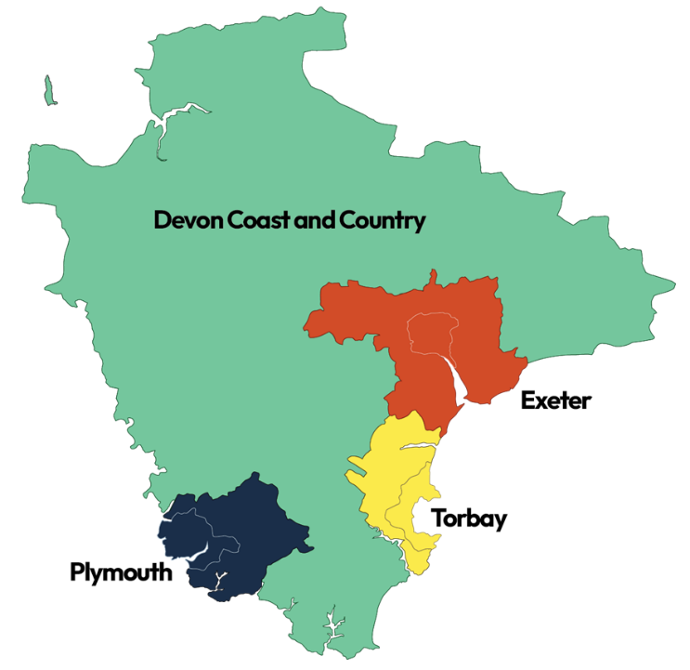
Local Government Reorganisation – Government Decision Announced
The biggest piece of local government news is the Government's decision on the future structure of local government in Devon.
On 16 July 2026, the Government confirmed that the current two-tier system of Devon County Council and District Councils will be replaced by four new unitary authorities. The model chosen was based on proposals submitted by Exeter and Plymouth City Councils.

What does this mean?
Under the new arrangements:
- Devon County Council will eventually cease to exist.
- District councils, including Torridge District Council, will also be abolished.
- A new Devon Coast and Countryside unitary authority will be created covering the majority of rural Devon, including Torridge.
- Expanded unitary authorities will also be created for Exeter, Plymouth and Torbay.
What happens next?
The Government has made it clear that:
- There will be no immediate changes to local services.
- Detailed transition planning will now begin.
- Elections to the new authorities are expected in 2027.
- The new councils are anticipated to become fully operational in 2028.

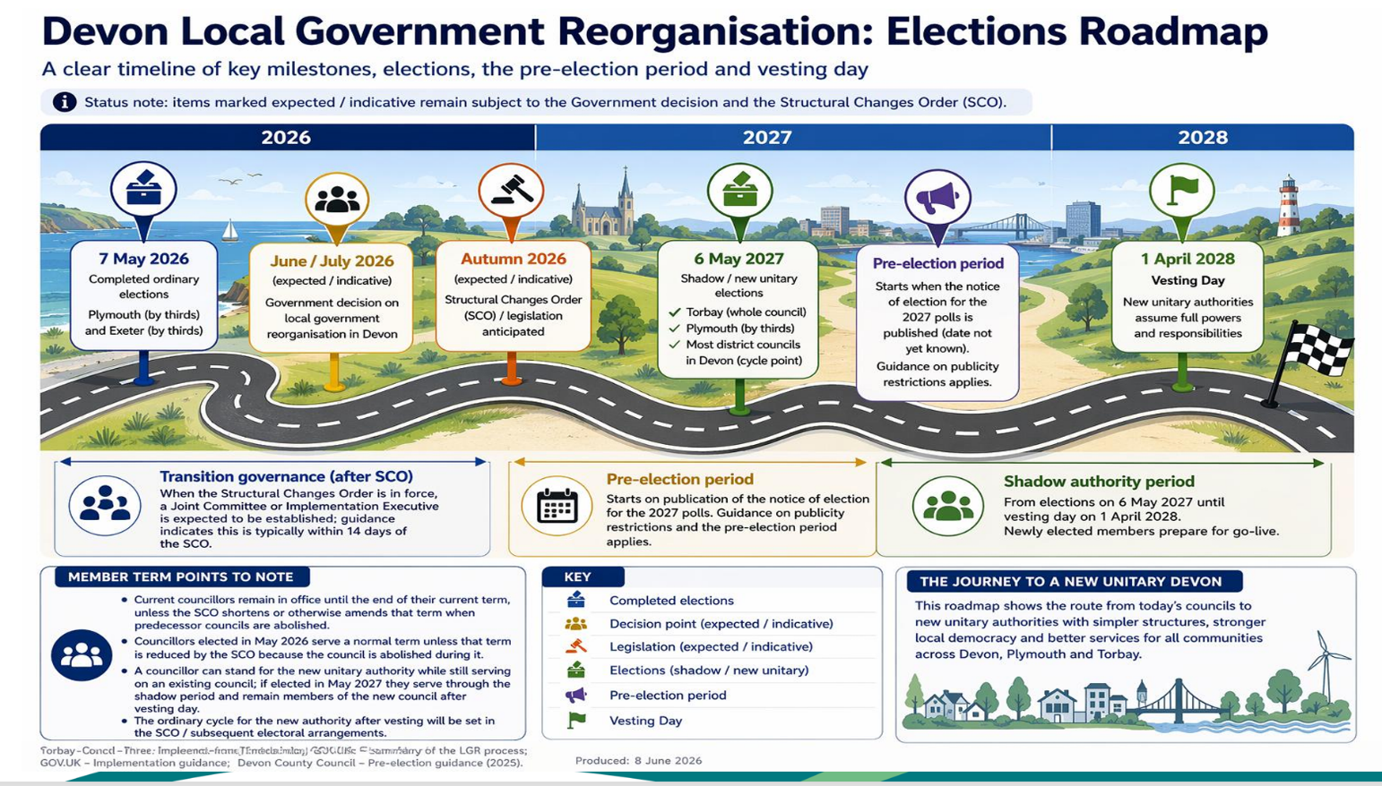
What does this mean for Torrington Rural?
There is still much detail to be worked through, but parish councils should be aware that:
- Services currently split between Devon County Council and Torridge District Council will eventually be delivered by a single authority.
- There will be important discussions about local representation, service delivery, assets, staffing and community engagement.
- It will be vital that rural communities continue to have a strong voice during the transition process.
As your County Councillor, I will continue advocating for effective representation of our rural communities and ensuring that parish councils are fully engaged as plans develop.
My Concerns About the Government's Decision
I am deeply disappointed by the Government's decision to adopt the Exeter and Plymouth proposal. Of all the options put forward for Devon, I believe this is by far the worst outcome for Torridge and many rural communities across the county.
I was outraged by the Government's announcement, which appeared to focus almost exclusively on the benefits for Plymouth and Exeter whilst giving insufficient consideration to the needs and challenges of rural Devon. In my opinion, the Government has failed to properly represent the interests of the many people who live, work and run businesses in our rural communities.
Distance and Accessibility
The proposed Devon Coast and Countryside authority covers a huge geographical area with no urban centre. Travel times from the furthest north to south and west to east parts of the authority could exceed two hours.
Financial Pressures
Although the Devon Coast and Countryside authority may have the largest population of the four new unitaries, it will also inherit by far the largest rural road network (5,000 miles to maintain).
As we all know, many of these roads are already deteriorating before our eyes, particularly those in the rural areas. I am concerned that residents in what includes some of the most deprived areas of the South West could face increasing council tax pressures as the new authority struggles to raise sufficient funding to maintain highways and essential infrastructure to an acceptable standard.
Lack of a Natural Administrative Centre
Unlike Plymouth, Exeter and Torbay, the new rural authority does not include a major urban hub which could naturally serve as its administrative base.
Questions remain about where the authority would be headquartered and whether significant expenditure may eventually be required to establish suitable offices or meeting facilities in a more central location. Taxpayers will rightly expect close scrutiny of any such costs.
Economic Consequences
Many of the most deprived communities in Devon are located within the proposed Devon Coast and Countryside authority.
By separating these communities from the county's two largest economic centres, there is a fear that opportunities linked to urban growth, investment and regeneration may become more difficult to access in the future.
Rural Representation
Above all, I am concerned that this model weakens the voice of rural Devon at a time when our communities already face significant challenges. It is vital that villages, market towns and farming communities are not overlooked during the transition process.
In summary, I have grave concerns that this version of Local Government Reorganisation will have significant negative ramifications for residents living within the proposed Devon Coast and Countryside authority. I will continue to challenge proposals where necessary and advocate strongly for the interests of rural Devon.
The executive summary of the proposal selected by Government can be viewed here:
Exeter and Plymouth Joint Executive Summary:
https://exeter.gov.uk/media/x1allonv/exeter-and-plymouth-joint-executive-summary-final.pdf
Proposed Devon Data Campus and Battery Storage Site
Many constituents will already be aware of the emerging proposal from Xlinks for a large-scale AI data centre campus and Battery Energy Storage System (BESS) between Great Torrington, Weare Giffard and Huntshaw.
According to information released by the developer, the project would occupy approximately 850 acres, with large data-centre warehouses 40m tall, extensive battery storage infrastructure (2,700 shipping containers) and associated facilities.
Community Concerns
Significant concerns have been raised by residents and local organisations regarding:
- Loss of productive agricultural land.
- Landscape and visual impact.
- Effects on biodiversity.
- Energy demand and grid capacity.
- Water usage.
- Public health concerns arising from noise and heat.
- Traffic impacts during construction and operation.
- The scale of development within a rural landscape and UNESCO Biosphere area.
Current Position
Importantly:
- No planning application has yet been submitted.
- Separate applications are expected for the data centre (outline planning) and battery storage facility (full planning).
- Public consultation events originally planned for July have been postponed by Xlinks and we are awaiting dates for further engagement.


My Position
I have been advised by some that, as a district and county councillor, I should remain neutral and sit on the fence until further information becomes available. However, having learned more about existing data centres and being told the scale of the proposal, I quickly came to the conclusion that I could not remain silent.
I am hugely concerned by what is being proposed and in my view, we already know enough to conclude that this is the wrong development in the wrong place.
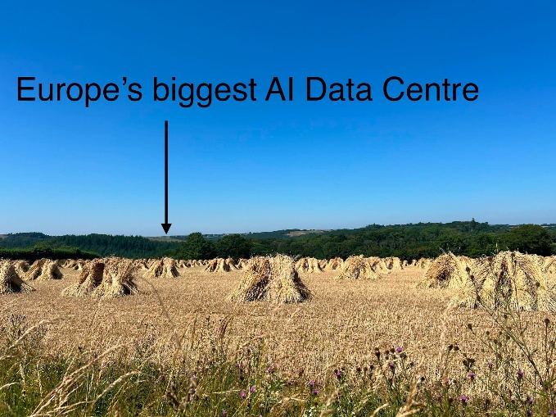
The scale of this proposal cannot be overstated. If approved, the Devon Data Centre would be the biggest data centre development in Europe, alongside what would also be one of the largest Battery Energy Storage Systems (BESS) in the world. This is a proposal of unprecedented scale for rural Devon and is difficult to even comprehend, It is bigger than the town of Great Torrington.
The proposal would remove 850 acres of productive agricultural land within a UNESCO Biosphere landscape. It includes areas of historic significance, including listed farmhouses, important wildlife habitats and land that contributes to our food security.
If a development of this scale can be built here, then it opens the door for similar developments almost anywhere in the country.
That is why I believe we must take a stand now. I cannot sit back and watch some of our most treasured landscapes being lost forever. The consequences of decisions like these are irreversible and irreparable. We must fight to protect our area, our communities and the countryside that makes North Devon and Torridge so special.
Whilst I fully support investment, job creation and economic growth in Torridge, I remain wholly unconvinced that the claimed benefits outweigh the enormous impact this proposal would have on our communities, countryside, infrastructure and quality of life.
I will continue to work with residents, parish councils, campaign groups, our Member of Parliament and colleagues across all political parties to ensure this proposal receives the highest possible level of scrutiny and challenge.
I have already written to Government ministers and Devon MPs together with other county council cabinet members, raising concerns about the location of hyperscale AI infrastructure in rural areas and calling for Rural Impact Assessments to become a mandatory part of the decision-making process. I have also submitted a Parliamentary petition calling for an urgent moratorium on data centres and large-scale battery storage facilities outside designated AI Growth Zones. I am currently waiting to find out whether the petition has been accepted onto the gov.uk website before I can promote it.
Protecting rural communities and ensuring that national policy properly reflects rural realities will remain a key priority for me.
Transparency and Consultation
I am extremely disappointed that Xlinks chose to postpone its public information events at such short notice.
At a time when public concern is growing, this decision does little to inspire confidence and only reinforces the widespread feeling that local residents are not being properly informed.
It is absolutely essential that there is full disclosure of Xlinks' plans, together with a detailed explanation and evidence base for the claims and figures presented in the company's initial leaflet. Too many important questions remain unanswered.
I am increasingly concerned about the direction of travel from national Government regarding nationally significant infrastructure projects, particularly measures designed to accelerate approvals and reduce local influence. There is a growing perception that the voices and needs of rural communities are being sidelined in pursuit of centrally imposed targets and priorities.
As always, I am willing to work constructively across party lines where it is in the interests of local residents. On this issue, I believe it is vital that we all work together to ensure this proposal is subjected to the highest possible level of scrutiny and that local people have a genuine opportunity to influence decisions that could fundamentally and permanently alter the character of our area.
Site Visit with Devon County Council Leader
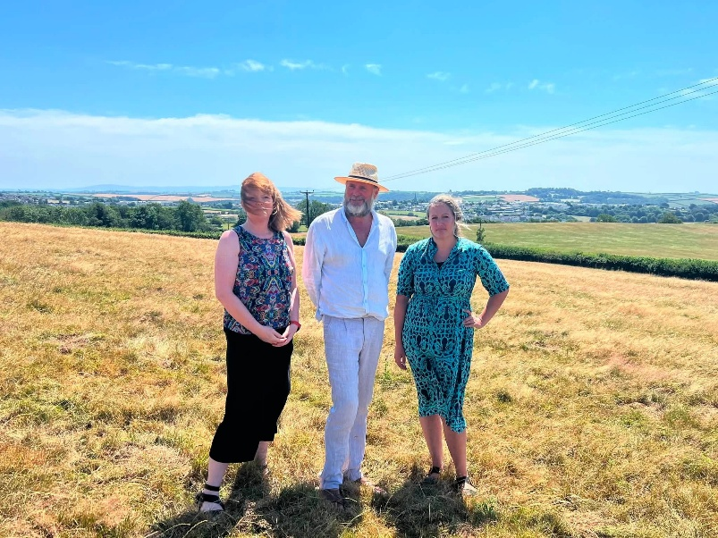
I was delighted to welcome Devon County Council Leader Cllr Julian Brazil and Cabinet Member Cllr Denise Bickley to Great Torrington recently.
As well as visiting the primary school, it was a valuable opportunity to walk part of the public footpath network that leads directly into the centre of the proposed data centre site and to drive around the wider development area, including the proposed 100-acre BESS site.
I would encourage anyone interested in these proposals to visit the area themselves (but make sure you stick to the public footpaths!). Standing within the landscape and seeing the panoramic views stretching from Dartmoor to the North Devon coast provides a valuable perspective on the scale of what is being proposed and why so many local people regard the location as wholly inappropriate.
Local Plan Consultation
A reminder that Torridge and North Devon Councils want to hear from residents, businesses and service providers.
What do you value about living here?
This is your opportunity to influence the future of the place we call home.
The first scoping consultation for the new Local Plan is now open and closes on 11 August 2026.
https://www.torridge.gov.uk/article/22565/Residents-invited-to-help-shape-new-local-plan-for-North-Devon-and-Torridge
Biodiversity Recording
For anyone taking part in the Big Butterfly Count, please consider using the iNaturalist app to record your observations and locations.

It would also be extremely helpful if residents could use the app to record other wildlife, including bats, birds, insects and other species in and around the proposed data centre and BESS sites.
This information can help build a clearer picture of the biodiversity that exists within the area and could provide useful evidence about the environmental importance of the site.

Recent Devon County Council Cabinet Matters
Financial Stability and Transformation
Cabinet has continued to monitor pressures in:
- Adult social care.
- Children's services.
- Home-to-school transport.
- Special Educational Needs and Disabilities (SEND).
Like many councils nationally, Devon continues to face increasing demand for statutory services, making long-term financial sustainability a major priority.
Roads and Infrastructure
Investment in Devon's highway network remains a priority, including:
- Road maintenance.
- Pothole repair programmes.
- Bridge maintenance.
- Active travel and transport initiatives.
These remain particularly important for rural areas where reliable transport links are essential for residents, businesses and farming communities.
Economy and Rural Communities
Cabinet has continued to support:
- Economic growth initiatives.
- Rural business development.
- Skills programmes.
- Infrastructure projects intended to improve connectivity and resilience across Devon.

What You Can Do
I strongly encourage all residents, businesses, farmers, community organisations, town councils and parish councils to make their voices heard.
The decisions currently being discussed, whether through Local Government Reorganisation or the proposed Devon Data Campus and Battery Energy Storage System, have the potential to shape the future of our area for generations to come.
You can help by:
- Taking part in all future consultations and public engagement exercises.
- Responding to the North Devon and Torridge Local Plan consultation before 11 August 2026.
- Attending public meetings and information events when they are announced.
- Encouraging neighbours, friends and family members to engage in the process.
- Recording local wildlife, habitats and biodiversity using the iNaturalist app and participating in initiatives such as the Big Butterfly Count.
- Sharing evidence about the environmental, agricultural, heritage and community value of the area.
- Contacting your local councillors, Member of Parliament and relevant decision-makers to ensure our voices are heard.
- Working constructively together across communities and political boundaries to protect what makes North Devon and Torridge special.
No one cares more about this area than the people who live and work here. If we do not speak up, others will make decisions on our behalf. Whether your concerns relate to the future of local government, the protection of our countryside, the preservation of productive farmland, or the character of our communities, now is the time to become involved.
The proposed Devon Data Campus would be the biggest data centre development in Europe and one of the largest battery storage developments in the world. If approved, it would permanently transform a significant area of rural North Devon. Equally, the decisions being taken through Local Government Reorganisation will have lasting consequences for how services are delivered and how rural communities are represented in the future.
Together, we can ensure that rural Devon is not overlooked and that the interests of our communities are properly represented in the decisions that will shape our future.

Supporting Our Rural Communities
The coming months will bring important discussions about both Local Government Reorganisation and major infrastructure proposals affecting North Devon and Torridge.
I know that many residents feel strongly about these issues, and rightly so.
My commitment remains to:
- Champion rural Devon.
- Protect productive farmland and our countryside.
- Ensure robust scrutiny of major developments.
- Maintain strong local representation throughout the reorganisation process.
- Work constructively with parish and town councils to secure the best possible outcomes for our communities.
If your council would like a further briefing on either the Local Government Reorganisation programme or the proposed Devon Data Centre, please do not hesitate to contact me. I am regularly posting on my councillor Facebook page, and this is a good place to go for updates too.
Kind regards,
Cllr Cheryl Cottle-Hunkin
Devon County Councillor – Torrington Rural Division
Cabinet Member for Rural Affairs
Devon County Council

