

GREAT TORRINGTON TOWN COUNCIL

Minutes of the Full Council Meeting held on Wednesday 3rd June 2026 at 7pm in the Committee Room, Great Torrington Town Council, Castle Hill, Great Torrington

MEMBERS PRESENT:
Cllrs K Allin, B Ashley-Martin, L Bright, P Cloke, J Insull, J Isaac, L Kite, D Maisey, S Mills and D Parish (Chair)

ALSO, PRESENT:
Jennie Smithson, Town Clerk and Charlotte Kirby, Deputy Town Clerk

COUNCIL REFLECTION
Cllr Parish read the Council Reflection to start the meeting.

APOLOGIES
The following Members gave their apologies in advance of the meeting: Cllrs C Bright (family commitments), Cllr Brown (illness), Cllr Sanders (work commitments) and Cllr Smith (illness)
Apologies were proposed and seconded to be accepted. Vote outcome:
For | 8
Against | 0
Abstained | 2
Outcome | RESOLVED

Apologies were not received for Cllrs Rosslee or Watson-Davies.

DECLARATION OF INTERESTS
Cllr Mills declared other registerable interests in agenda items 14 (Graffiti Project) and 15 (Market House). Cllr L Bright declared other registerable interests in agenda items 15 (Market House) and 23 (CCTV). Cllr Kite declared a non-registerable interest in agenda item 10 (Correspondence) and an other registerable interest in agenda item 18 (Working Groups).

POLICE REPORT
Members were provided with a copy of the online crime reports from the Devon and Cornwall Police website. The Town Clerk has been liaising with the local police team regarding a breakdown of crimes within the Violence and Sexual Crimes category, however there appear to be differences between the data being presented on the Devon and Cornwall Torrington Rural Police website and that available to the local police team. The Town Clerk will follow up to request that the police investigate why there are discrepancies in the data.
Members agreed that a more meaningful way to review police activity and crime data in these meetings moving forward would be for a member to regularly attend the monthly online meeting hosted by the police specifically for local councils and then feed back to Full Council meetings. Cllr Mills agreed to attend where possible as this meeting sometimes clashes with this council’s monthly Full Council meetings.
ACTION: Town Clerk to request that the local police team investigates why there are discrepancies in the data they use vs that presented on the Devon & Cornwall Police website.
ACTION: Share MS Outlook invitation to the police meetings with Members.

REPORT FROM COUNTY COUNCILLOR: CLLR COTTLE-HUNKIN
Cllr Cottle-Hunkin was unable to attend this evening’s meeting and supplied a report (see Appendix A).

REPORT FROM TORRIDGE DISTRICT COUNCILLORS: CLLR L BRIGHT
- Torridge District Council (TDC) has allocated an additional £38,000 in funding towards the development of two Playzones: one in Holsworthy and the other in Great Torrington. These projects are now ready to move forward through the planning approval stages.
- The process for developing a new Local Plan for Northern Devon will be launched shortly. After the initial meeting, District Councillors will feed back to this council on the proposed timelines and when Town Council consultation will be required.

PUBLIC CONTRIBUTIONS
None.

CONFIRMATION OF MINUTES

Annual Business Meeting minutes: 13 May 2026
Approval of the meeting minutes was proposed and seconded. Vote outcome:
For | 9
Against | 0
Abstained | 1 (LB)
Outcome | RESOLVED

The following meeting minutes were noted by Members:
- Draft Planning Committee Meeting minutes: 6th May 2026

MATTERS ARISING
None.

CORRESPONDENCE AND MATTERS BROUGHT FORWARD BY THE CHAIR AS A MATTER OF URGENCY
- Thursday 4th June is ‘Devon Day’. Members were asked to share anything they are doing to celebrate on social media.
- The council has been contacted by a local resident to complain about food being left out for seagulls on the viewing areas at Castle Hill and in Sydney House car park near the recycling bins. The Town Clerk has forwarded the complaint to the Commons Conservators and TDC’s Environmental Protection team.
- A letter from Sir Geoffrey Cox, MP has been received regarding upgrades to broadband connectivity in the area. The letter outlines several addresses within the parish of Great Torrington which will not be included in the planned upgrade.
- An impact report has been received from Citizen’s Advice which the Town Clerk has forwarded to members for review.
- Crimestoppers has informed the council that they recently positioned their advertising van in the town square and will be circulating leaflets about their services as a result of the grant funding awarded to them by this council recently.
- Bluecoat CofE Primary School: the council has become aware today of a meeting next week to discuss funding for the school, along with a statement issued by the school governing body. Cllrs Cloke, Allin, L Bright and Parish are planning to attend the meeting which will take place at 6pm on Wednesday 10th June at the Town Hall.

QUESTIONS FROM MEMBERS SUBMITTED NO LATER THAN NOON, TUESDAY 2ND JUNE 2026
None.

END OF YEAR DOCUMENTS TO BE CONSIDERED AND APPROVED:
- Internal Audit Report:
It was proposed and seconded to accept and approve the Internal Audit Report for FY25/26. Vote outcome:
For | 10
Against | 0
Abstained | 0
Outcome | RESOLVED

- Annual Governance Statement:
It was proposed and seconded to approve the Annual Governance Statement for FY25/26 in section 1 of the AGAR document. Vote outcome:
For | 10
Against | 0
Abstained | 0
Outcome | RESOLVED

- Annual Accounting Statement:
It was proposed and seconded to approve the Annual Accounting Statement for FY25/26 in section 2 of the AGAR document. Vote outcome:
For | 10
Against | 0
Abstained | 0
Outcome | RESOLVED

- Town Clerk Report:
The Town Clerk summarised her report regarding residual funds for FY25/26. It was proposed and seconded to approve the Town Clerk’s recommendation to transfer residual funds from FY25/26 totalling £20,628.86 into general reserves. Vote outcome:
For | 10
Against | 0
Abstained | 0
Outcome | RESOLVED

MAYORAL EVENTS, CHARITABLE DONATIONS:
It was agreed to retain the cap of £10 per event as a reclaimable donation to other Mayor’s charities when the Mayor or Deputy Mayor (or other representative of this council) attends events hosted by other local mayors. Donations of this nature can be reclaimed from the Mayor’s annual allowance.

GRAFFITI PROJECT: TORRI YOUTH
Torri Youth has approached the council for approval to host another graffiti project in Calf Street Skate Park this summer on a wall dedicated to this purpose within the park.
It was proposed and seconded that this project be approved by members. Vote outcome:
For | 10
Against | 0
Abstained | 0
Outcome | RESOLVED

MARKET HOUSE
- Heads of Terms
The Deputy Town Clerk informed Members that following further discussions with TDC regarding a lease for Market House, a draft Heads of Terms (HoT) agreement has been shared (provided to members in advance of tonight’s meeting).
This latest HoT document outlines the expectations of this council as the proposed tenant in terms of maintenance responsibilities and does not include anything structural within the building. Maintenance is limited to the floorboards and painting of the internal surfaces (walls, ceiling and columns) and interior doors.
As tenant, the town council would be responsible for paying rent of £1,350 per annum (pro-rated for FY25/26) as well as annual buildings insurance costs (estimated to be approximately £500 per annum) and £200 towards the landlord’s legal costs in setting up the HoT.
The term of the HoT is 5 years from 01 Apr 2025.
Members discussed how the room has been used historically and queried what the museum’s plans are for this room in the future. They also queried who would be responsible for the light fittings in the room as the ceiling is very high and would likely require a scaffold tower should any repairs be required to the lighting.
It was agreed that the town council should meet with representatives of the museum to discuss their plans for the space in Market House before Members will agree to sign the HoT. This agenda item will be added to the agenda for the next Full Council meeting in July.
ACTION: Arrange meeting with museum representatives to discuss Market House plans before next Full Council meeting on 22 July 2026.
ACTION: Update TDC with outcome of this discussion.

- Painting Costs
It was proposed and seconded that a contribution of £300.00 towards the cost of painting the internal walls of Market House would be given to TDC. Vote outcome:
For | 10
Against | 0
Abstained | 0
Outcome | RESOLVED

FINANCIAL UPDATE:
Approval of the following financial updates were proposed and seconded. Vote outcome:
Item: | Accounts Paid: Apr 2026 | Bank Reconciliation: end Apr 2026 | Fund Transfers: Apr 2026 | Payments & Invoices Over £500: Apr 2026
For | 10 | 10 | 10 | 10
Against | 0 | 0 | 0 | 0
Abstained | 0 | 0 | 0 | 0
Outcome | RESOLVED | RESOLVED | RESOLVED | RESOLVED

ASSERTION 10 UPDATE:
The Town Clerk outlined areas where the town council is not currently compliant with Assertion 10 requirements. Two of these items (publishing pay multiple and land owned by the town council) can be addressed promptly. Issues with the website not meeting WCAG 2.2 AAA will be addressed with a newly designed website which is scheduled for this financial year.

WORKING GROUPS UPDATE:
- Increasing Physical Activity Working Group: The first meeting of this group took place recently. The group is looking at potential locations for a Great Torrington-based Park Run and they are planning to visit local pump tracks to determine feasibility of something similar in Great Torrington. Discussions are also underway regarding establishing a cricket hub in Great Torrington following the closure of several local village cricket teams. Active Devon is looking to be able to provide funding to launch a Park Run alongside funding from other community groups
- Emergency Planning Working Group: The Town Clerk is in the process of reaching out to potential members for this group.

HEALTH & SAFETY:
- An asbestos register has been provided by the landlords of Castle Hill.
- A recent review by our Health and Safety advisor has highlighted that the copy of the gas certificate for the building has expired (Town Clerk to request an update from the landlords) and the electrical safety certificate for the building is due to expire in September 2026.
- The two-year contract with Seal Safety for Health and Safety matters will be coming to an end soon. Members will be asked at a future meeting whether they wish to renew.
- Cllr Isaac advised members he is fully qualified with the Institute of Occupational Health and Safety.

EVENTS: SUMMER MUSIC PROGRAMME:
Staff are busy working on booking acts for this summer’s music programme in the town centre.

FUNDING REQUESTS:
None.

MEMBER UPDATES:
- St Michael’s Church: Cllr Insull updated members on a very successful music event at St Michael’s on Saturday 30th May. The church hopes to offer more of these types of events in the future.
- Bickford Centre: Cllr Cloke informed members that it is the Bickford Centre’s 50th anniversary soon. If members have any suggestions for what they could do to celebrate please let him know.
- Tarka the Otter Comes to Town Adventure Trail: Cllr Isaac updated members on the launch of the trail during half-term. There have been >1200 views on Facebook and >100 trail packs were sold in the first week. The project is self-funding so any profits from selling the packs will go back into creating more packs. Other local businesses have expressed interest in sponsoring more carvings, the logistics of which will need to be discussed further with relevant organisations. Local businesses have also been selling otter-related merchandise. Cllr Parish thanked Cllr Isaac for all his hard work and doing a fantastic job on the trail.

Closed session: To resolve to exclude the press and the public to progress matters of a confidential nature under the Public Bodies (Admission to Meetings Act) 1960 and Local Government Act 1972 ss 100 & 102.
Approval to move into the closed session was proposed and seconded. Vote outcome:
For | 10
Against | 0
Abstained | 0
Outcome | RESOLVED

CCTV MONITORING ARRANGEMENTS:
TDC’s CCTV monitoring team has confirmed they now have additional capacity and can accommodate monitoring the proposed CCTV cameras in Great Torrington. The Town Clerk outlined the proposed costs associated with this option vs the costs associated with other options discussed previously.
It was proposed and seconded to select TDC’s CCTV monitoring facility to host and monitor Great Torrington’s proposed CCTV provision. Vote outcome:
For | 8
Against | 0
Abstained | 2 (DM & LB)
Outcome | RESOLVED

YOUNG PERSONS AWARD NAME CONSIDERATION:
The Town Clerk shared a number of suggestions for naming the Young Person’s Award. Members were asked to consider those proposed and this topic will be discussed again at a future meeting where a decision will be made.
ACTION: In the meantime, the Town Clerk will put another article in The Crier asking for suggestions from the local community.

Vote to come out of items to be discussed which exclude the press and the public:
It was proposed and seconded to come out of the closed session. Vote outcome:
For | 10
Against | 0
Abstained | 0
Outcome | RESOLVED

EQUALITY, DIVERSITY AND INCLUSION:
The council confirms that decisions made at this meeting were in line with Great Torrington Town Council policies.

DATE OF NEXT MEETING:
Full Council Meeting: Wednesday 22nd July 2026 at 7pm.

Meeting closed at 8:38pm.

Signed ………………………………………… Date ………………………..

Appendix A: County Councillor’s Report
Libraries:
Great news for Devon’s libraries! Following the extensive consultation which received more than 25,000 responses, Devon County Council’s cabinet voted unanimously to support a range of positive proposals and a new vision for Devon’s library service. This includes an extra £2M investment which will ensure there is no reduction in staffed opening hours over the next two years, as well as supporting transformation of our libraries to make them more resilient; making the most of all of the opportunities that came out of the consultation. This includes creating partnership libraries with local organisations and town councils, integrating more supportive services into library spaces, modernising the service to enable extended opening hours beyond traditional staffed opening hours, and training up volunteers (6000 people responded to the consultation saying they would be interested in volunteering in their local library!). As well as this we are investing an extra £100k into the book fund, and will be completely removing book fines which are a traditional and outdated concept: experience from other libraries shows that removing them entirely encourages more people to use the library, and actually makes it easier to get books back too!
£2 million cash boost secures future of Devon libraries - News
Pothole Pandemic and Revival of the Road Warden Scheme:
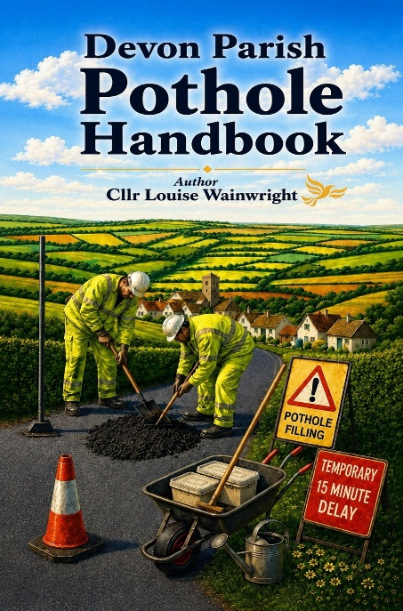
You may have seen on Spotlight recently, my colleague Cllr Louise Wainwright has been working extremely hard in reviving the road warden scheme to help improve the situation with our roads as much as possible. Call for volunteers to help fix Devon's £1bn pothole problem - BBC News
In parts of South Devon the road warden scheme has been working well, and we would love to see this happening right the way across Devon. If you know any keen and willing volunteers, do ask them to get in touch, and as a parish council I would be grateful if you could call 0345 155 1004 or email: communityselfhelp@devon.gov.uk to get the ball rolling and sign the parish up to the scheme.
I have printed copies available (one for each Parish) and for anyone wanting to take a look it is also available on Cllr Wainwright’s website here too: Potholes | My Site 6
More info here on DCC website: Road Warden Scheme - Devon Highways
A Positive Direction for Devon
Things are very much on the up at Devon County Council. We have reported a £10 million underspend in our first year as a new administration. This is not because we have cut services or held back spending, but because we are managing resources more effectively and efficiently. Significantly, both Children’s and Adults’ Services have delivered a surplus, something that very few councils are currently able to achieve. This reflects improved financial discipline, stronger decision making, and a collaborative approach between councillors and officers.
Importantly, these savings are now being reinvested into the services that matter most to residents, including highways, libraries and frontline support.
Investing in Our Roads
Improving our roads remains one of the biggest priorities I hear from residents. I have been out and about locally in the highways van, inspecting issues first hand and working closely with officers to push for improvements. We are investing another additional £4 million into highways, including rapid response repair crews and the continuation of a successful repair trial. This allows teams to fix multiple defects in one visit, making repairs more efficient, longer lasting and better value. It is important to note that the past year has largely been delivered under the previous administration’s budget. I am hopeful that with continued investment and a good summer of working conditions, we will begin to see more significant and visible improvements to our road network in the months ahead.
Council unveils £4m boost for road repairs - News
Supporting Children, Families and Foster Carers
Improving outcomes for children and young people remains our top priority. The latest Ofsted report has recognised real progress, including stronger leadership, improved stability and more effective support for families. Social workers are building better relationships and more children are receiving the right help at the right time. There is still more to do, but we are moving in the right direction and remain fully committed to improving outcomes for our most vulnerable children. We are also continuing to appeal for more foster carers. I recently attended the Hearts and Homes conference, which was both emotional and inspiring. Our foster carers do an incredible job and make a lasting difference to children’s lives. It is important to know that fostering does not have to be a long term commitment. Short break and weekend care are also hugely valuable and much needed.
New approach to recruiting foster carers in Devon showing early impact
Ofsted report highlights progress in Devon children’s services
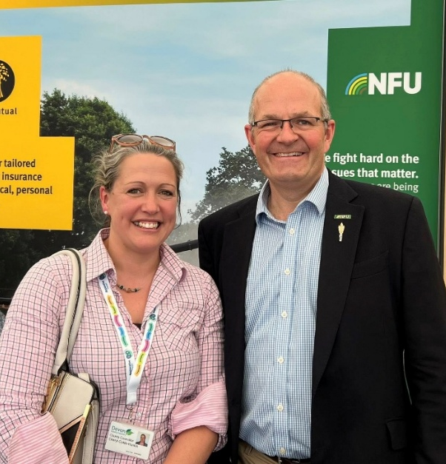
Celebrating Devon’s Rural Life
It was fantastic to attend the Devon County Show, which is always a highlight of the year and a wonderful celebration of our rural communities. It was a great opportunity to meet residents, farmers and local organisations.
I was particularly pleased to speak with NFU President Tom Bradshaw. We discussed important issues including food security, the impacts of climate change on farming, and the farm inheritance tax. These conversations are vital to ensuring that the voice of rural Devon is heard at a national level.

Engagement with Torrington Rotary Club
I was pleased to be invited to speak at the Rotary Club of Torrington, reflecting on my first year as a County Councillor.
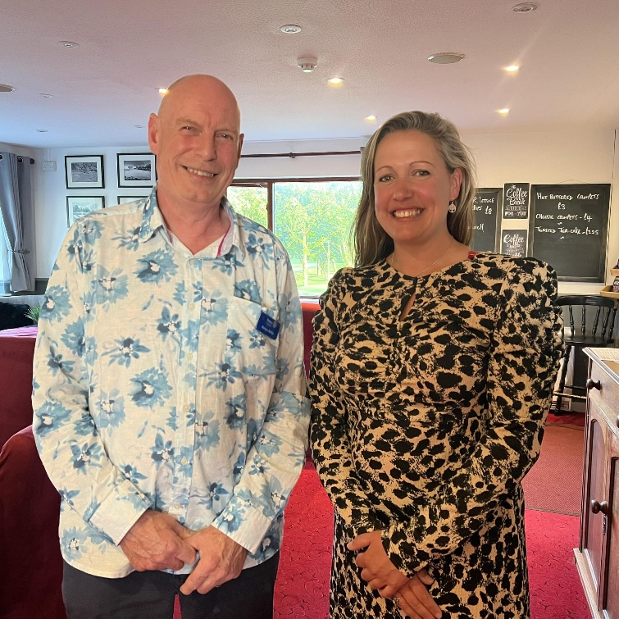
I highlighted key initiatives including the “Places to Go, Things to Do” youth grant scheme, the need for foster carers through Fostering Devon, and the reinvigorated Road Warden Scheme supporting local volunteers with highways issues.
I also spoke about my role as Cabinet Member for Rural Affairs and the importance of partnership working across agencies and with local communities.
Thank you to the Rotary Club, and in particular Martyn Butler and members, for their warm welcome and continued service to the community.

