

GREAT TORRINGTON TOWN COUNCIL

Minutes of the Annual Parish Meeting held on Wednesday 18th March 2026 at 7pm in the Great Hall, Great Torrington Town & Community Hall, High Street, Great Torrington

MEMBERS PRESENT:
Cllrs K Allin, C Bright, P Cloke (Mayor), J Insull, J Isaac, L Kite, D Maisey, S Mills, D Parish and D Smith

ALSO, PRESENT:
Jennie Smithson, Town Clerk, Charlotte Kirby, Deputy Town Clerk, Sharon Lambert (Accounts), Kate Cooper (Admin Assistant) and Members of the Public

WELCOME
The Mayor welcomed Councillors and members of the public to the meeting.

CONFIRMATION OF MINUTES: ANNUAL PARISH MEETING 19th MARCH 2025
Approval of the meeting minutes was proposed and seconded. Vote outcome:
For | 10
Against | 0
Abstained | 0
Outcome | RESOLVED

HIGHLIGHTS OF THE TOWN COUNCIL’S YEAR: CLLR PHIL CLOKE, MAYOR OF GREAT TORRINGTON
Cllr Cloke summarised the activities of the Town Council during the course of the last year – see Appendix A for full details.

THE PLOUGH ARTS CENTRE UPDATE: EMMA MARSTON, CHIEF EXECUTIVE OFFICER
Emma Marston updated the meeting on how the grant awards given to The Plough Arts Centre by the Town Council have helped them during the course of this financial year. The initial £9,000 grant enabled them to secure additional match-funding from other sources in order to facilitate much-needed repairs and improvements to the structure of the building. Some of the improvements should result in much lower energy bills moving forward (e.g. triple glazed sash windows).
The emergency grant of £15,000 awarded to The Plough by the Town Council later in the year helped with supporting their operating costs following a significant depletion of their reserve funds. This grant was enhanced by additional funding from Torridge District Council for two years.
The Plough’s strategy to streamline their programme of events and therefore reduce staffing and utilities costs is working with the organisation now breaking even.
Emma wholeheartedly thanked the Town Council for it’s generous contribution towards its costs this year.

LOCAL GOVERNMENT REORGANISATION: CHARLOTTE KIRBY, DEPUTY TOWN CLERK
Charlotte Kirby summarised plans for local government reorganisation in Devon which will result in the creation of a single tier of government throughout the county. See Appendix B for copies of the slides presented.

COMMUNITY EMERGENCY PLANNING: MARTIN RICH, DEVON COMMUNITIES TOGETHER
Martin Rich discussed the importance of communities creating emergency plans to deal with unexpected situations and major events, for example, last year’s Mill Street Common fire.
He advocated community engagement with a team of local people identifying risks, how they might be prevented or mitigated, first responders, how the emergency services can be supported during an emergency, planning for community recovery and then learning and adapting following real-life experiences.

TARKA THE OTTER AND FRIENDS TRAIL: CLLR JASON ISAAC
Cllr Isaac has created a children’s book following Tarka the Otter and his friends on a trail around Great Torrington and the Commons. Alongside the book, there will be wooden sculptures of Tarka the Otter’s friends dotted along the trail and merchandise will be available to purchase in some of the town centre shops.
Cllr Isaac thanked local businesses and residents who have sponsored the wooden carvings. He hopes to launch the trail in time for the May half term holiday.
Any money raised through the sale of the books will be reinvested in community projects in Great Torrington.

TO RECEIVE QUESTIONS AND CONSIDER MATTERS RAISED BY REGISTERED ELECTORS WITHIN THE TOWN OF GREAT TORRINGTON
Emergency Planning:
Qu: A member of the public asked whether there is already an Emergency Plan in existence for Great Torrington or whether on the night of the Mill Street Common Fire, the emergency services managed the situation.
A: Representatives from Devon & Somerset Fire & Rescue Service, who were on duty on the night of the fire, confirmed that on the night, the fire service worked closely with the police to manage the situation. There was no overall emergency plan in place for Great Torrington. Such a plan would have helped in terms of pre-identifying a suitable ‘hub’ location for evacuations and for identifying vulnerable people in advance. One of the representatives confirmed he currently sits on the Local Resilience Forum for emergency planning and would be happy to assist Great Torrington with creating a plan. Another member of the public (who has prior experience of working with an emergency plan) commented that this kind of activity brings the community together and great confidence-boosting training is offered by organisations such as Devon Communities Together for anyone wishing to be involved.

IDEAS BROUGHT FORWARD FROM THE PUBLIC FOR FUTURETOWN PROJECTS
Torri Youth: The young people of Torri Youth were asked recently to name 3 things that are important to them in Great Torrington:
- Youth Services: access to youth services in Great Torrington is limited and they would appreciate access to a Youth Development Officer and mental health support workers.
- Education: they would like to see education linked more closely with the community.
- Activities: activities such as roller skating, skate ramps and an improved skate park would be much appreciated, along with some recycling bins in Calf Street play park.
In addition, the young people at Torri Youth had mixed feelings about CCTV with some in favour and others not. They raised parking on Mill Street as an issue and that yellow lines throughout the town are not respected enough. Finally, they requested that there be public toilets accessible at night (currently the public toilets are closed in the early evening).
Great Torrington School: representatives from GTS brought forward the following ideas:
- More sporting events (in particular runs) in the town e.g. 5k and 10k races (which could be a way to raise money for charity) or establishing a Park Run in Great Torrington.
- Parking outside the school at drop-off and pick-up time, along with the associated increase in traffic at these times, is making it unsafe to cross the roads either side of the school, although Hatchmoor Road is the main issue with parents picking up children from Bluecoat School.
Cllr Cottle-Hunkin commented that she has been in consultation with Bluecoat School, Highways and local bus drivers to understand the issues on Borough Road, but was not aware that this issue extended to GTS. Other members of the public expressed their frustration with this issue.
Cllr Smith informed the meeting that a new pedestrian crossing has recently been approved by HATOC to go across New Road at the junction with Dick Hills Lane.
A member of the public suggested that the traffic warden be requested to visit the roads near the schools at drop-off and pick-up times rather than always focussing on the town centre.

REQUEST FOR FEEDBACK ON TOPICS FOR COMMUNITY CONSULTATION: JENNIE SMITHSON, TOWN CLERK
The Town Clerk invited members of the public to view the financial report for 2025/26 (see Appendix C) and to take a look at the various consultation stands around the room after the meeting in order to provide the town council with feedback on the following topics:
- CCTV
- Yellow Lines
- Local Government Reorganisation
- Street naming ideas

MEETING CLOSE
The Mayor thanked everyone who joined the meeting and closed proceedings at 8:31pm.

Signed ………………………………………… Date ………………………..

Appendix A: HIGHLIGHTS OF THE TOWN COUNCIL’S YEAR: Cllr Phil Cloke, Mayor of Great Torrington

So much has happened in the past year that I hardly know where to begin! I’ve mentioned the majority of the council’s and my own personal highlights in my monthly Crier reports. However, I am going to re-cap on a few memorable events.
In terms of sheer joy and entertainment, we have to start with last year’s Mayfair celebrations. Great Torrington is all about its community and nothing brings our town more together than our Mayfair celebrations. To have the honour of being your Mayor and overseeing this event was so very special. Obviously, I’m looking forward to this year’s Mayfair, our Round the Tree Race and Walking Carnival.
But our council has been involved in implementing similar events! The VE Day celebrations were fantastic: music, dancing, food and celebrations came together to create a super day. I also seemed to rejuvenate our Pannier Market and hopefully laid the foundations for its future use.
Similarly, keeping with the musical theme, a very varied and successful programme of street music did wonders in putting smiles onto the faces of both shoppers and visitors to the town.
I also believe that the purchase of some new lights made our Christmas celebrations that extra bit special.
As a council we have strived to provide something for all ages, both the very young and the more senior members of our community. For example, our recent half-term activities for youngsters which included pottery and science workshops, went down a storm! And we have also introduced the chance for Young People to be nominated for a new Annual Award.
Similarly, we have provided funding for dementia workshops in our town’s library. I am pleased to report that feedback from both those living with dementia and their carers has been incredibly positive.
We have strived to keep you safe and healthy in various ways. Recently we renewed the contract on 5 of our town’s defibrillators. And the extreme hard work of Jennie Smithson, our Town Clerk, has led us to securing a grant of £10,000 to be spent on installing CCTV within our town.
Like all councils, we receive a limited budget. It is thanks to the incredible professional and skilled work of our office team that we are in a position to accommodate the grant applications we receive and still manage to keep a balanced and secure budget. All applications are carefully considered on their merit and the way the outcomes will benefit our town. Examples of grants we have given, both large and small, are displayed in the hall this evening for you to study. Two of the biggest recipients were The Plough Arts Centre who received a total of £24,000, and The Globe Hotel which received £5000. We will be hearing from The Plough this evening.
We are constantly seeking ways to improve our environment. We have earmarked £10,000 to enhance and refurbish the children’s play park area at Trafalgar Drive. And Councillor Dave Parish and I have been involved in wildflower seed planting at Jubilee Woods. The introduction of reusable poppy wreaths for our Remembrance Day services has saved waste whilst raising funds for the Royal British Legion.
To conclude, a few of my personal highlights have been visiting the Bluecoat School (in full regalia) to help deliver the pupils Christmas lunch and having the opportunity to share in Doreen Turner’s 100th birthday celebrations at Woodland Vale Care Home.
And of course, even if my mind forgets, my legs remind me of my completing the Round the Tree Race in a Mayor’s fancy dress costume (with a chocolate gold chain) last year. And this year – let’s wait and see.
I hope that you enjoy the rest of this evening and I will be happy to have a chat with you over refreshments later.

Appendix B: LOCAL GOVERNMENT REORGANISATION

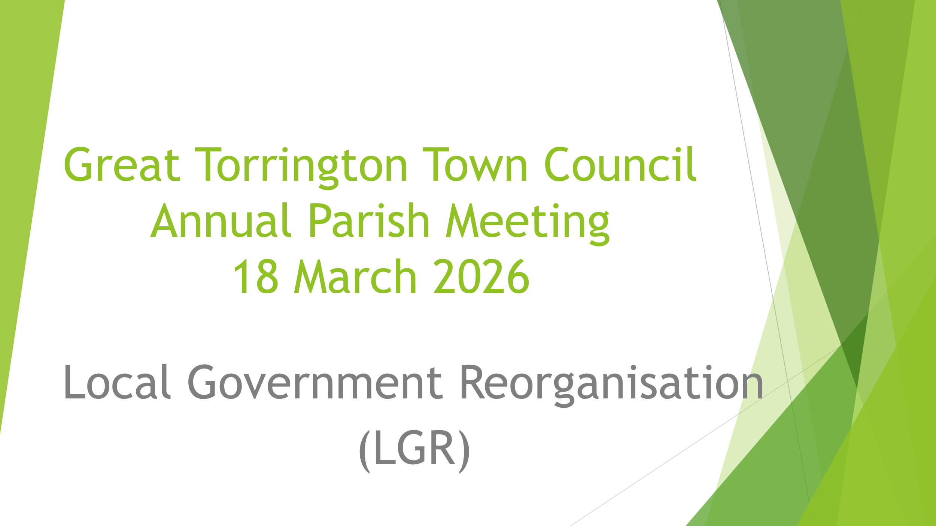

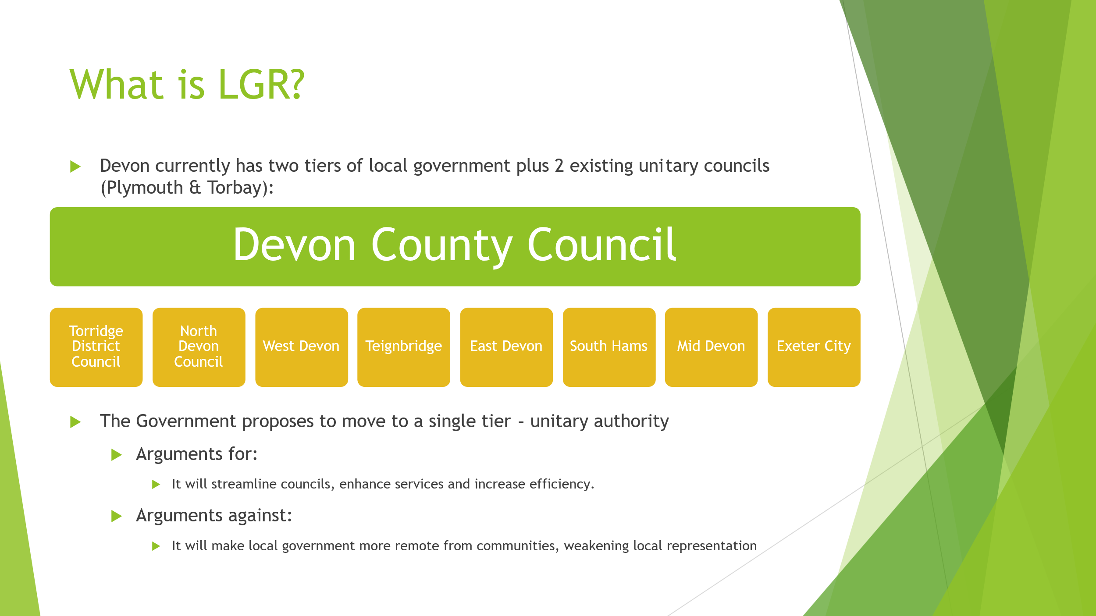

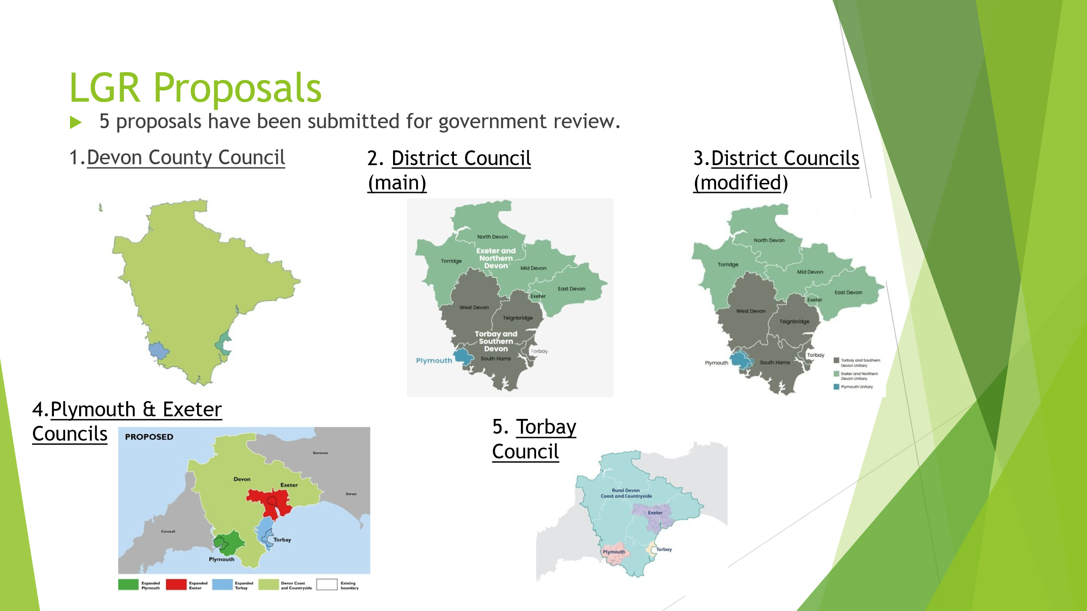
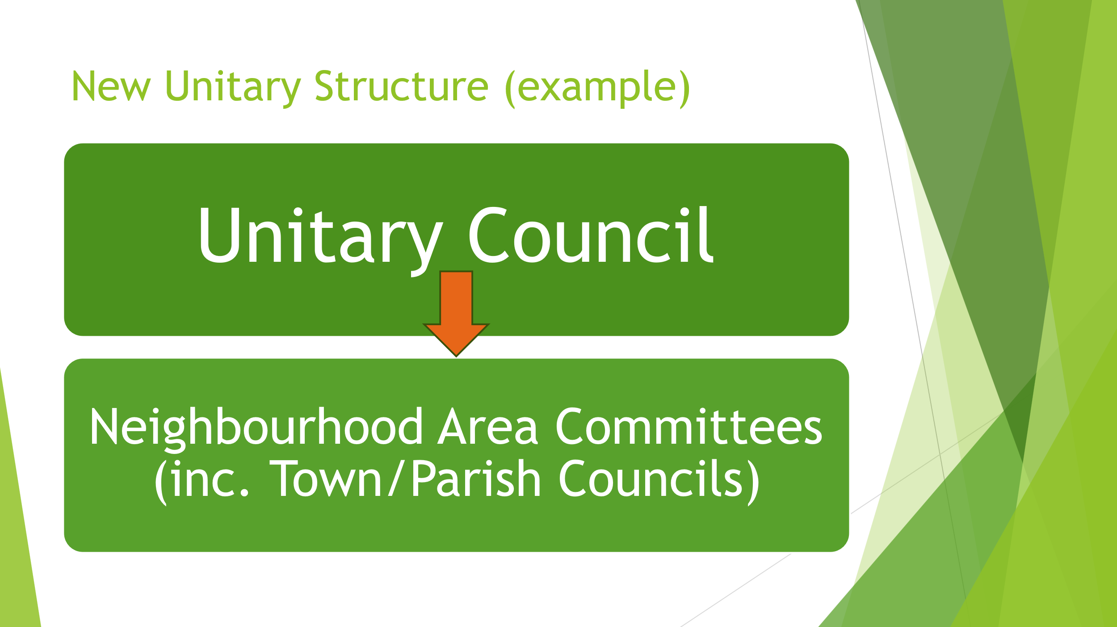
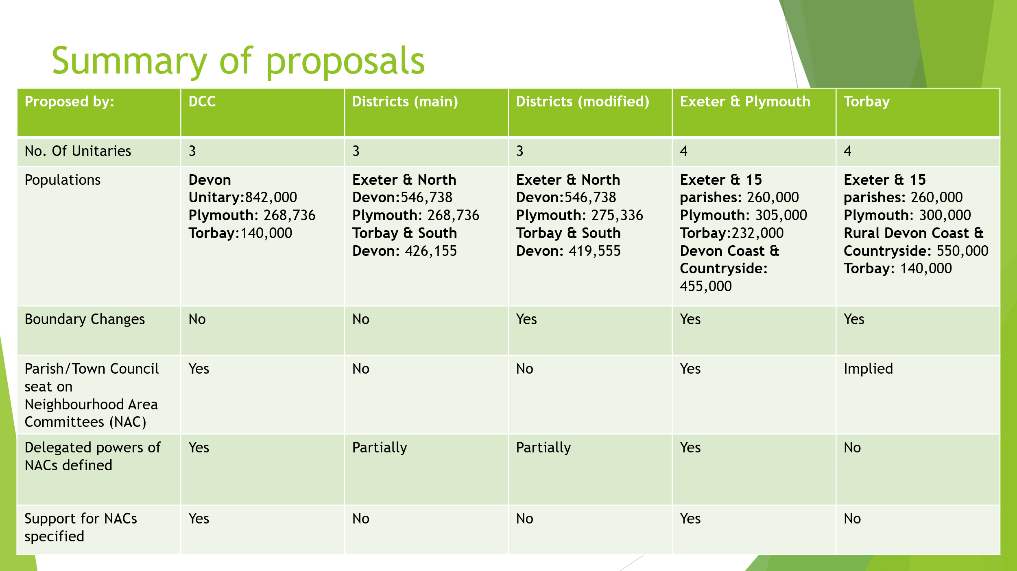
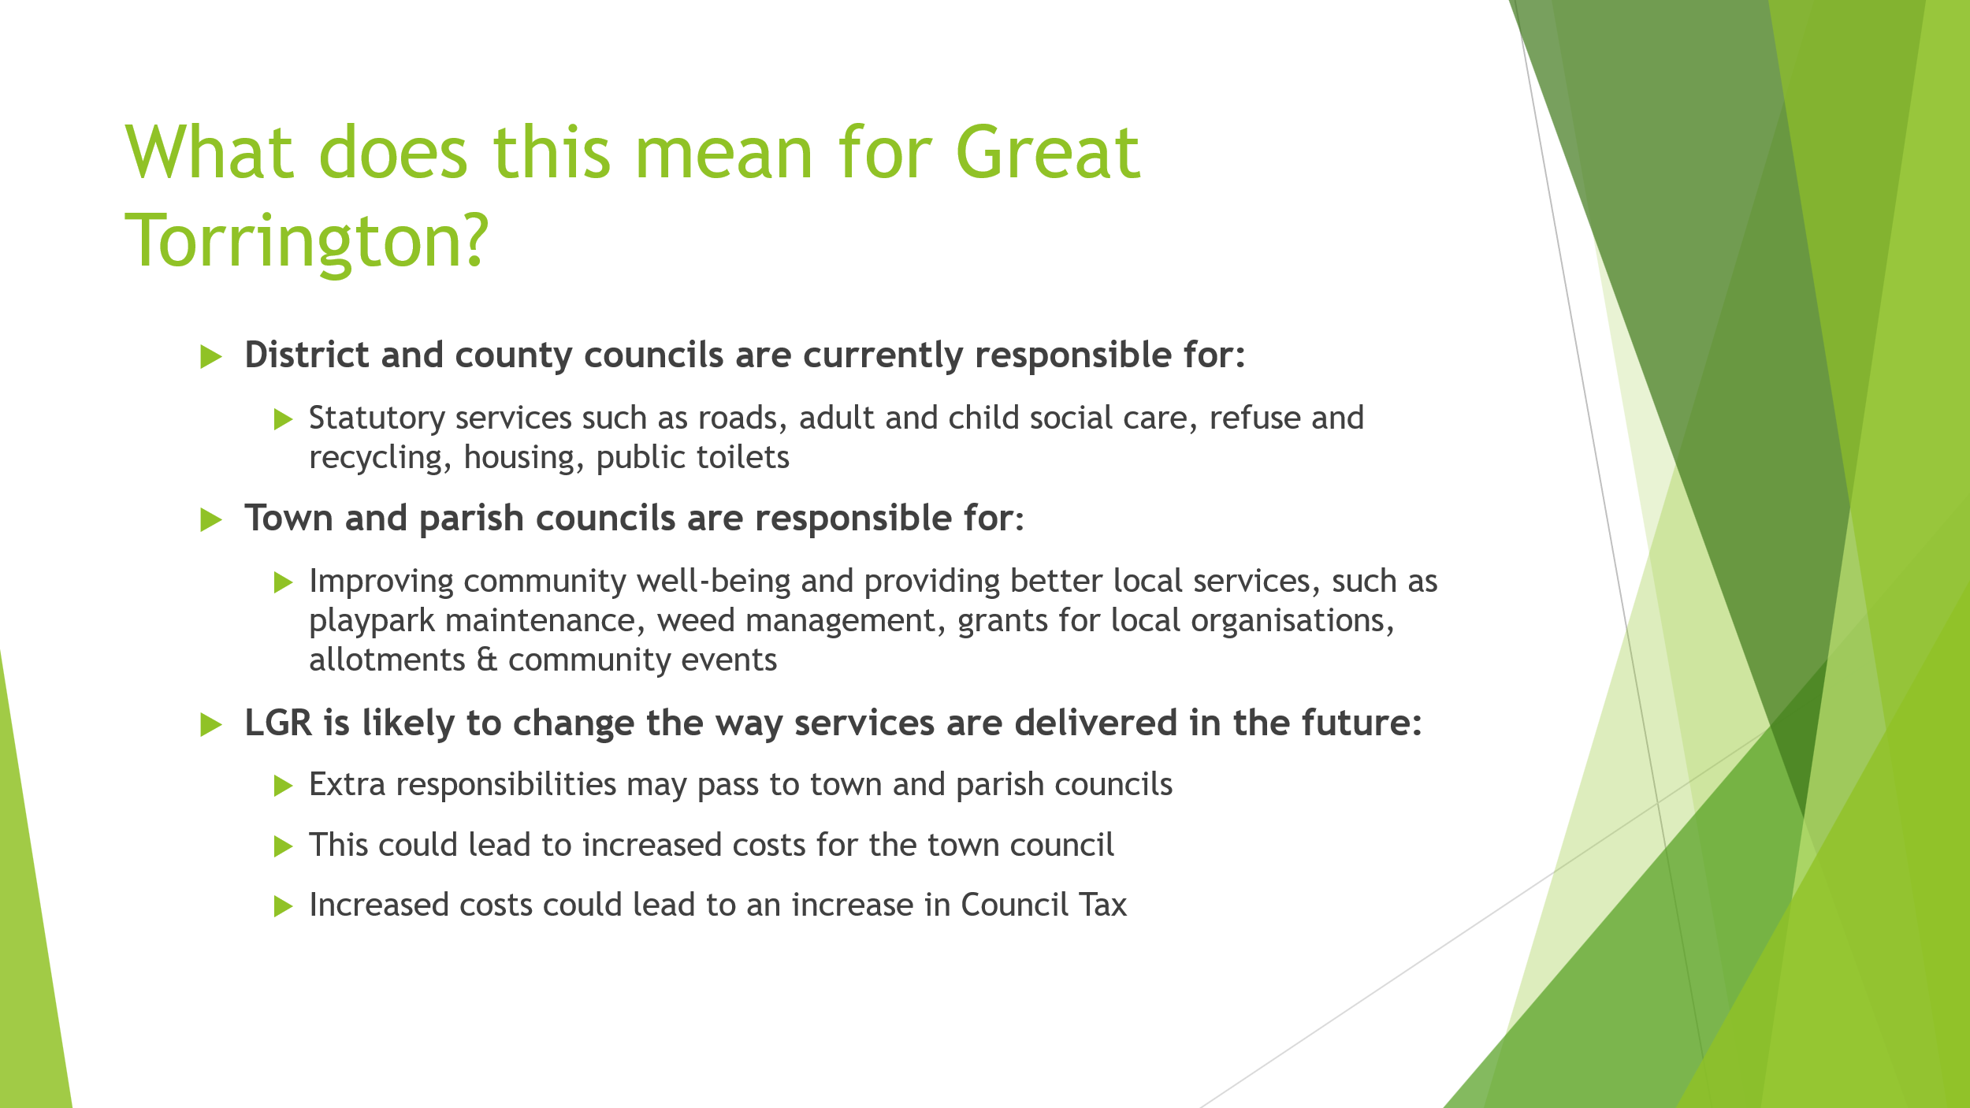
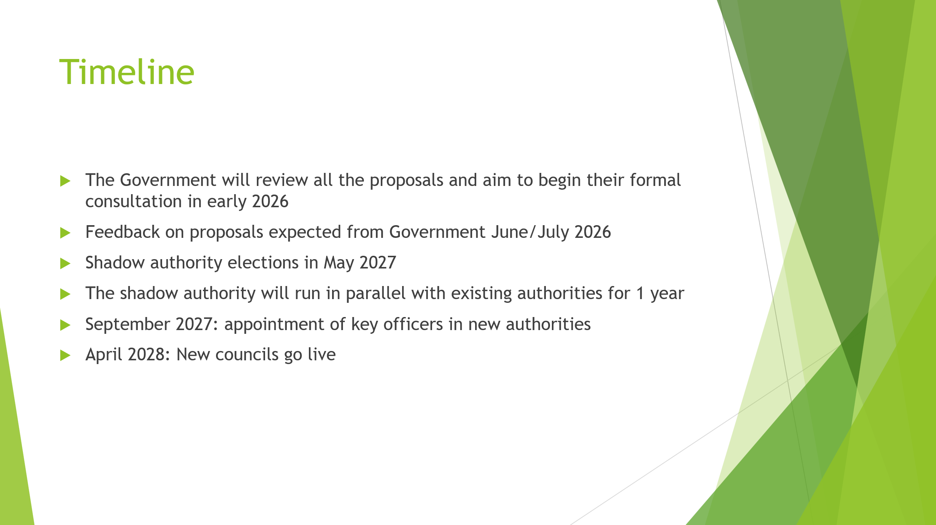
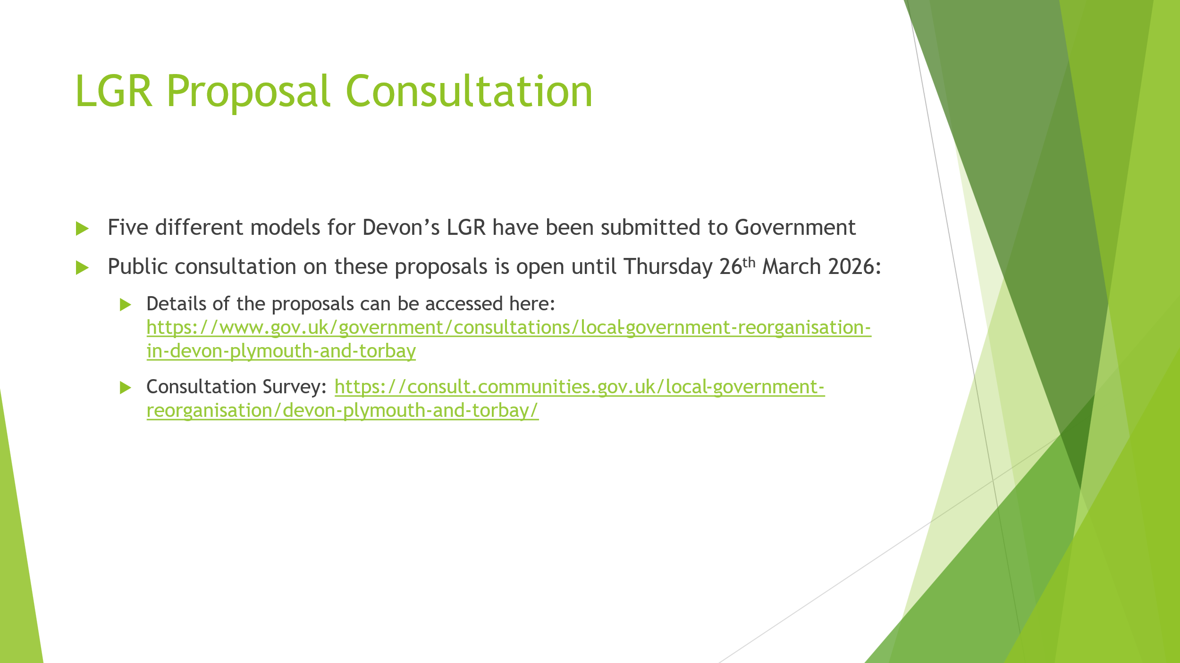
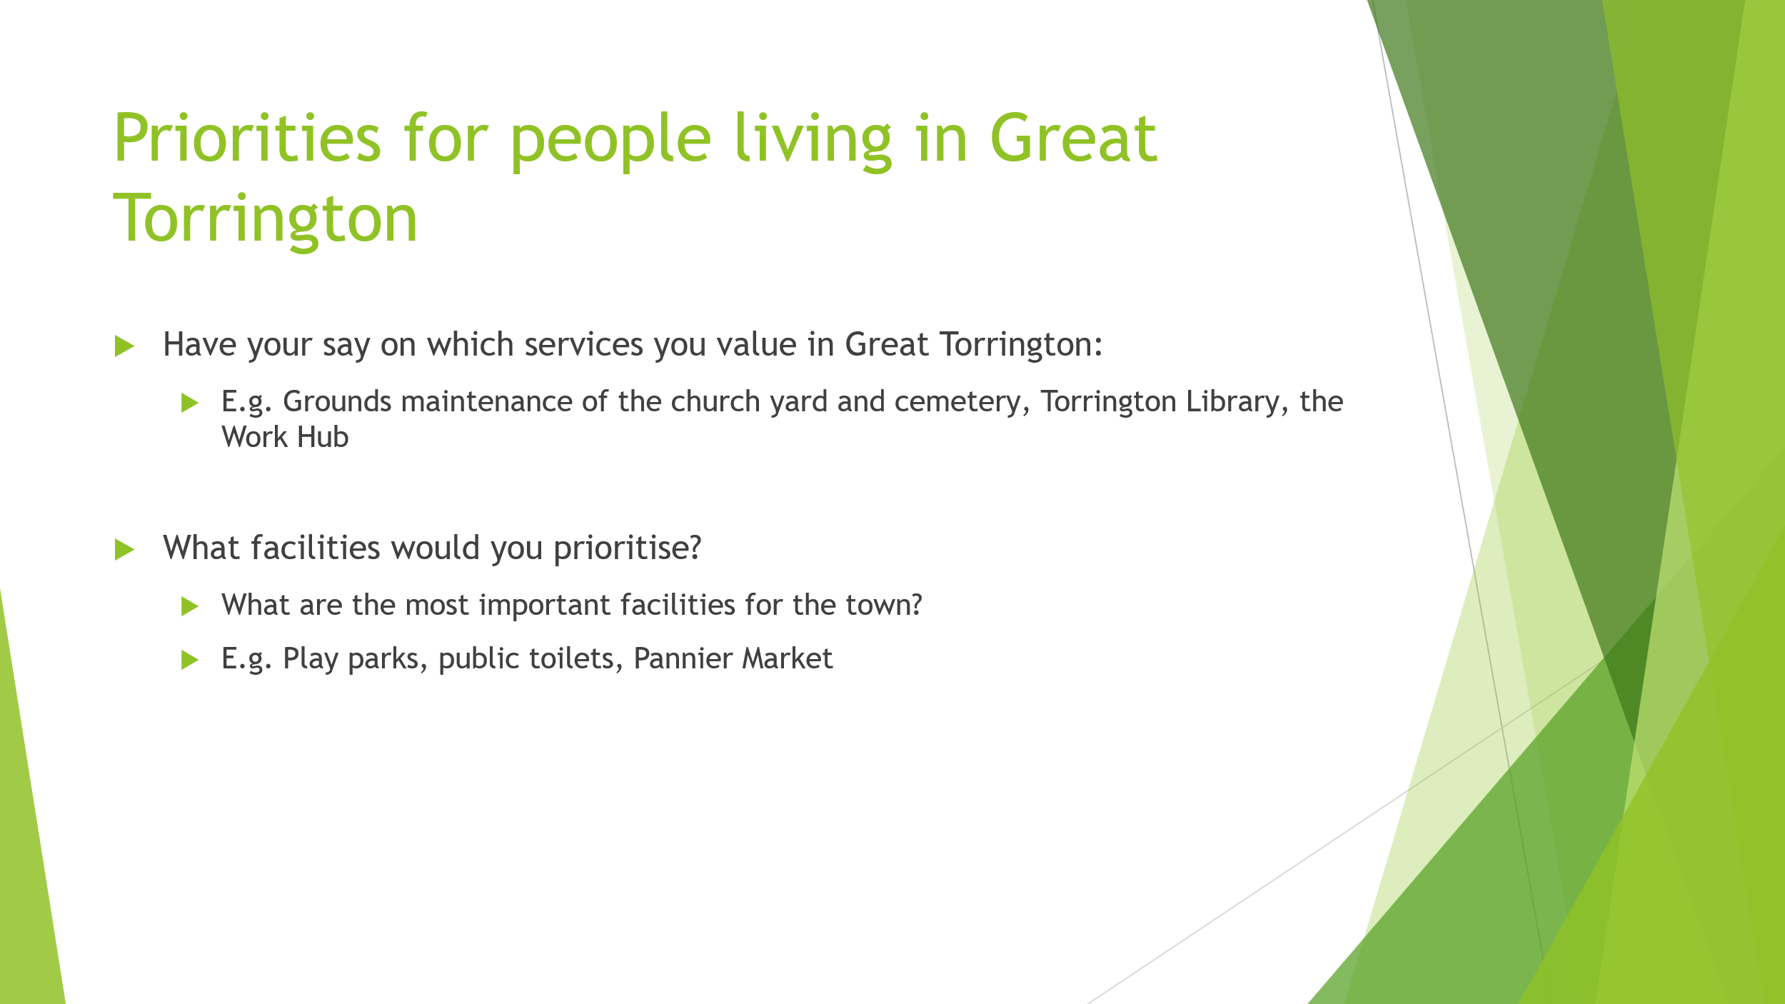

Appendix C: FINANCE REPORT FOR TOWN/PARISH MEETING 2025/2026

INTRODUCTION
We are in the process of finalising accounts for 2025/26 and are on course to be within budget.
Summary:
- Finance reporting:
Members of the Council approve financial information each month, to monitor spending and budget.
Accounts paid information is provided to councillors monthly, all payments are authorised by the Clerk/Deputy Clerk and two councillors.
Reserves and Balances
Over recent years, following advice and in-line with good practice we have been mindful to create a healthy reserves balance. Reserves stood at £215,555.08 at the end of March 2025. The underspend for financial year 2024/25 was added to this sum. During 25/26 a large grant was paid to The Plough Arts Centre (£15K) and two large sums were allocated to ring fenced reserves for the Trafalgar Drive project (£10K) & for Windy Cross maintenance (£5,250).
At the end of February 2026 reserves were as follows:
    - General Reserves: £176,205.23 (including interest brought forward)
    - Reserves for new equipment: £8,505.00
    - Reserves for play parks: £14,572.00
    - Reserves for elections: £6,000.00
    - Reserves for Ringfenced projects £14,270.50
    - Interest 4/25-2/26: £1,591.11

Total: £221,143.84

Planned spending for 25/26 included a substantial transfer from reserves of £23,650 into the budget allocated as follows:
- £4,400 Grants, COMPLETE
- £2K Reserves new equipment, £2K Reserves Parks, COMPLETE
- £10K Trafalgar Drive Play Park, RINGFENCED IN RESERVES
- £5,250 (refurbishment/maintenance Windy Cross monument). RINGFENCED IN RESERVES
For various reasons including incidents of vandalism, the Trafalgar Drive project has not yet started. Also, the Windy Cross work has not been completed due to a planned community project to open the well which has been delayed. The funds allocated to these projects will be ringfenced in reserves and completed as soon as circumstances allow.
During the 25/26 financial year members allocated a large emergency grant of £15,000 from the reserves to The Plough Arts Centre.
The Play zones project has also been delayed and £17,000 of the GTTC reserve funding is committed to this collaborative project with TDC and the Football Foundation.
This spending has reduced the reserves quite considerably although they remain within the recommended level of between 3-12 months of running costs. It is important that GTTC now retain the level of reserves as we move towards Local Government Reorganisation which is likely to involve transfers of services and therefore increased costs to GTTC.

In-year Grants 25/26:
The budget for 2025/26 included an in-year grant fund of £3,000 for applications received throughout the year and outside of the formal Grant Application period. Beneficiaries so far are:
- Torrington Rugby Club,
- Living Well with Dementia,
- South West Event Management (Christmas activities),
- Abbeyfield,
- South West Ambulance Service,
- Torrington Rotary (Memorial Stone 1646),
- Torrington Library Elevenses,
- Crimestoppers Southwest.
Accounts 2025/2026
Accounts for 2025/26 are in the process of being reconciled and prepared. Once the figures have been finalised any underspend will be moved to the reserves account or ringfenced for specific projects in accordance with good practice and the Reserves Policy/Protocol. (Minus the £7,500 retained for the 26/27 budget).
- Forward Planning - Budget 2026/27
The budget for 2026/2027 reflects several rising costs to the council, including the increase in employers National Insurance Contributions, the need for a paid storage facility for the maintenance team, due to the closure of the School Lane depot, essential maintenance on the council owned building 14 South Street, and the monitoring costs of the proposed CCTV installation project.
In addition to these increased costs, for the first time the tax base figures from TDC have shown a decrease in Band D equivalent properties, meaning that without GTTC increasing the precept request from the 25/26 figure, the cost to a band D household in Great Torrington would increase by 1.37% (£1.93 for the year).
The impact of the increased budget on residents has been reduced by retaining £7,500 from the predicted underspend for 25/26 into the 26/27 budget.
Members agreed an increase in the budget of £3,550 from £288,750.00 for 2025/26 to £292,300 for 2026/2027.
The increase in precept is £21,769.00 from £257,931.00 for 2025/26 to £279,700.00 for 2026/27. (The increase in the precept this year is larger than the increase in budget due to the transfer from GTTC reserves into last year’s budget.)
For council tax purposes it will result in an increase of 9.92% for the Great Torrington Town Council element.
This equates to an increase of £13.99 per year for Band D properties and an increase of £9.32 for a Band A property per year.

Grant allocations for 26/27:
- As part of the budget setting process the Town Council has awarded grants for the 26/27 financial year via the precept totalling £27,650 (This includes £2,900 for an in-year grant pot). A total of £5,489.99 has been allocated via the Commons Allotment Charity. A copy of the grant allocations is available here tonight and on the GTTC Website.

AUDIT

The Internal and External Audit Reports for 2024/2025 were presented to Members, at the June 2025 and September 2025 Council meetings respectively; they were noted and approved.

