
Castle Hill
Great Torrington
Devon EX38 8AA
Tel: 01805 626135
Office Hours: 9.00am to 1.00pm Tues/Wed/Thurs
Town Clerk: Jennie Smithson E-Mail: admin@great-torringtontowncouncil.gov.uk

TO THE COUNCILLORS OF GREAT TORRINGTON TOWN COUNCIL

EXTRAORDINARY MEETING OF THE COUNCIL

You are hereby summoned to an EXTRAORDINARY MEETING OF THE COUNCIL
at the date and time below:

MEETING TO BE HELD AT THE COUNCIL COMMITTEE ROOM, CASTLE HILL, SOUTH STREET, GREAT TORRINGTON.

Tuesday 21st April 2026 at 6:30 pm
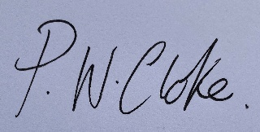
Mayor
In accordance with The Public Bodies (Admissions to Meetings) Act 1960 members of the public are welcome to attend. It is requested that mobile phones are switched to silent for the duration of the meeting. There is a legal right to film/record/photograph/report public meetings.

AGENDA

Apologies for absence

Declaration of interests

10-minute period for public contributions

To consider correspondence or other business especially brought forward by the direction of the Chairman

Questions from Members submitted no later than noon, 20th April 2026

Closed session: To resolve to exclude the press and the public to progress matters of a confidential nature in line with the Public Bodies (Admission to Meetings Act) 1960 and Local Government Act 1972, ss 100 & 102 & paragraphs 1 and 2 of Part 1 of Schedule 12A of the Local Government Act 1972 (as amended), on the basis that individuals may be identifiable in relation to item 7.

To award the Howe Plate 2026

